Those Privileged to Serve Today Next Sunday
(Subject to change please check each Sunday morning)
Announcements ……….. Gary Niehaus … Glenn Brose
Opening Prayer ……….. Gary Niehaus …. Glenn Brose
Song Leader ……………… Dennis Mount …. Nate Stice
Scripture Reading ……….. Jerry Runk .….. Gary Niehaus
(Genesis 11:1-9)
Lord’s Table (Talk & Prayers) .. Glenn Brose … Dennis Mount
Closing Prayer …………… Nate Stice .….. Paul Carpenter
Greeters ……………….. Nate & Kendra …. Glenn & Mary
Communion Preparation for April ………….. Joyce

Birthdays April
Brittany Nesmeth 4/1 Mary Brose 4/6
Dennis Mount 4/10 Dana Mount 4/26

Anniversaries April

Re-Birthdays April

Weekly Budget – $1,250

Bible Correspondence Course and Home Bible Studies are available upon request.

Event room available for parties, meetings, or other gatherings.
Call Gary Niehaus, 513-519-5783, for information and booking.

Pearl Street
Church Of Christ

330 Pearl Street, PO Box 380
Lynchburg, Ohio 45142
WWW.pearlstchurchofchrist.com
WWW.Pearlstreetcofc@gmail.com
Facebook @ Pearl Street church of Christ
Contact: Dennis Mount – (937) 602-4194

Sunday Services
Bible Class ………..………………….. 9:30 AM
AM Worship …….…………………… 10:30 AM
PM Worship ..………………………….. 6:00 PM

Wednesday Service
Bible Study ……………………………….. 7:00 PM

Minister …………… Paul Carpenter (513-375-9992)

April 7, 2024
To Babel or Not to Babel
Genesis 11:1-9

Welcome
We wish to welcome you to services at the Pearl Street church of Christ. If you are a visitor, know that you are an honored guest. We invite you to join us every time we come together for worship or Bible study. If you have any questions about God, Jesus, Holy Spirit, Bible, Christianity, the worship service, or the church of Christ in general we would love to study with you to answer those questions.

Just A Thought
“Our vision is so limited we can hardly imagine a love that does not show itself in protection from suffering... The love of God did not protect His own Son... He will not necessarily protect us – not from anything it takes to make us like His Son. A lot of hammering and chiseling and purifying by fire will have to go into the process.”
Elisabeth Elliot

Weekly Memory Verse
PROVERBS 15:1 – ¹A soft answer turns away wrath, but a harsh word stirs up anger.

Bible Quiz Time
What was the price the Midianite traders paid for Joseph to his brothers?

Today’s Bible Text
GENESIS 11:7-8; English Standard Version
⁷Come, let us go down and there confuse their language, so that they may not understand one another’s speech.” ⁸So the LORD dispersed them from there over the face of all the earth, and they left off building the city.
Paul’s Portion
In the Broadway play, “Into the Woods” there is a song titled, “No One Is Alone”. In this song is the line, “You decide what is right, you decide what is good.” To be fair, in the context of the play this statement is more about avoiding prejudices than about making moral decisions. Although the play uses this statement to suggest that not all witches or giants are bad, society often has its own take on this statement. Probably ever since Noah and his family stepped off of the ark there has been, at least a little of, the attitude of “Don’t tell me what to do.” It seems that humanity has within it this feeling that they can determine what is right and wrong. This is often expressed with the words of, “Don’t judge me,” or simply, “Don’t judge.” In one extreme this attitude has resulted in humanity engaging in questionable behavior to say the least. Seeing the behavior and attitudes of much of society many have quoted Isaiah 5:20 “Woe to those who call evil good and good evil, who put darkness for light and light for darkness, who put bitter for sweet and sweet for bitter!” Obviously, the idea is that when humanity decides what is right or wrong they make poor decisions. Yet will humanity always choose poorly? Paul seems to suggest that humanity is able to choose what is right and what is good. In his letter to the Romans Paul states the following, “One person esteems one day as better than another, while another esteems all days alike. Each one should be fully convinced in his own mind.” Romans 14:5. The line of one being convinced in his own mind shows that people can decide what is right and wrong. Is this all Paul had to say on the subject? Of course not, just a couple of verses later Paul continues, “⁷For none of us lives to himself, and none of us dies to himself. ⁸For if we live, we live to the Lord, and if we die, we die to the Lord. So then, whether we live or whether we die, we are the Lord’s.” Romans 14:7-8. Paul is saying, “Yes, humanity decides what is right and wrong, but there are things to take into consideration when making the decision.” The major point to consider is that one is not an island unto themselves. This means that when deciding right and wrong how your decision affects the rest of humanity must be considered. Above this, however, how the decision aligns with God and His opinion of right and wrong must be considered. If your decision that something is right or good adversely affects your neighbor, or goes against the will of the Lord, then your decision needs to be reevaluated. Do not fall into the bitter for sweet trap.
Take Note
Tonight is our monthly Song Service, 6:00 PM
“Getting Healthier” class will meet tomorrow at 6:00 PM.
Showing of “The Chosen,” Season 4 begins tomorrow,
Monday, April 8, 7 PM.
Ladies Night Out is cancelled for the month of April. The
next Ladies Night Out is scheduled for May 7th.
One day Seminar, April 13, Fishinger Rd. Church of Christ.
Brief VBS meeting, Sunday April 21 after morning service.
Our next Fellowship meal will be Sunday April, 28.
Men’s Retreat, Fort Hill, May 17-18.
FYI: World Video Bible School web page (WVBS.ORG) is
currently not working. Refrain from handing out any of the
little cards in the foyer until the web page is fixed.

Traveling
Krista is in Illinois.

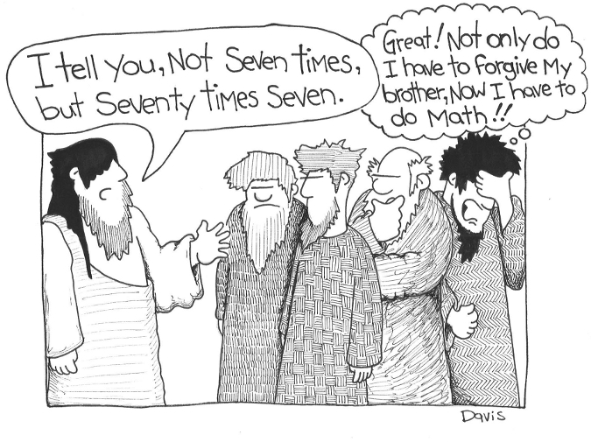
Just For Fun
Answer to Bible Quiz Time
Twenty shekels of silver, Genesis 37:28.
Illness and Prayer Concerns
The family and friends of Aralyn Slack.
Dorothy Warren, Krista’s mom, health concerns.
Bell Gardens residents, fire.
Mountjoy family, house fire.
Paul, relief from sciatica nerve pain.

Sympathy
Our sympathy goes out to the family and friends of Aralyn Slack in her passing.
We continue to be in prayer for the family and friends of: Frank Warren, Torrey Wolfer, Leymon Stice, Bill Yoho, Mike Droop.

You’re Invited to an exclusive showing
THE CHOSEN
Join us tomorrow evening for the first episode of

“The Chosen” Season Four. Don’t forget to invite your friends and neighbors!
To Babel or Not To Babel
GENESIS 11:1-9, ACTS 2:4-13

- BABEL – GENESIS 11:1-9
  - ONE PEOPLE
GENESIS 11:1 – ¹Now the whole earth had one language and the same words. ______________________________________________

  - MIGHTY CITY
GENESIS 11:3-4 – ³And they said to one another, “Come, let us make bricks, and burn them thoroughly.” And they had brick for stone, and bitumen for mortar. ⁴Then they said, “Come, let us build ourselves a city and a tower with its top in the heavens, and let us make a name for ourselves, lest we be dispersed over the face of the whole earth.”
_________________________________________________________

  - GOD DISPERSED
GENESIS 11:7-9 – ⁷Come, let us go down and there confuse their language, so that they may not understand one another’s speech.” ⁸So the LORD dispersed them from there over the face of all the earth, and they left off building the city. ⁹Therefore its name was called Babel, because there the LORD confused the language of all the earth. And from there the LORD dispersed them over the face of all the earth. _________________________________________________________

- NOT BABEL – ACTS 2:4-13
  - DIFFERENT NATIONS
ACTS 2:8-11 – ⁸And how is it that we hear, each of us in his own native language? ⁹Parthians and Medes and Elamites and residents of Mesopotamia, Judea and Cappadocia, Pontus and Asia, ¹⁰Phrygia and Pamphylia, Egypt and the parts of Libya belonging to Cyrene, and visitors from Rome, ¹¹both Jews and proselytes, Cretans and Arabians—we hear them telling in our own tongues the mighty works of God.” ________________________________________________

  - MIGHTY GOD
ACTS 2:11 – ¹¹both Jews and proselytes, Cretans and Arabians—we hear them telling in our own tongues the mighty works of God.”
_______________________________________________________
  - GOD UNITES
ACTS 2:42-47 – ⁴²And they devoted themselves to the apostles’ teaching and the fellowship, to the breaking of bread and the prayers. ⁴³And awe came upon every soul, and many wonders and signs were being done through the apostles. ⁴⁴And all who believed were together and had all things in common. … ^{the} And the Lord added to their number day by day those who were being saved. __________________________________________________

1 CORINTHIANS 1:10-13 – ¹⁰I appeal to you, brothers, by the name of our Lord Jesus Christ, that all of you agree, and that there be no divisions among you, but that you be united in the same mind and the same judgment. …
_________________________________________________________

- BE ONE PEOPLE
  - WORK AS ONE
ROMANS 12:4-8 – ⁴For as in one body we have many members, and the members do not all have the same function, ⁵so we, though many, are one body in Christ, and individually members one of another. ⁶Having gifts that differ according to the grace given to us, let us use them: …
_________________________________________________________

  - SPEAK AS ONE
PHILIPPIANS 2:1-2 – … ²complete my joy by being of the same mind, having the same love, being in full accord and of one mind.
________________________________________________________

  - LOVE AS ONE
1 JOHN 4:7-11 – ⁷Beloved, let us love one another, for love is from God, and whoever loves has been born of God and knows God. ⁸Anyone who does not love does not know God, because God is love. ⁹In this the love of God was made manifest among us, that God sent His only Son into the world, so that we might live through Him. ¹⁰In this is love, not that we have loved God but that He loved us and sent His Son to be the propitiation for our sins. ¹¹Beloved, if God so loved us, we also ought to love one another.
________________________________________________________

