Those Privileged to Serve Today Next Sunday
(Subject to change please check each Sunday morning)
Announcements ……….. Glenn Brose …… Jerry Runk
Opening Prayer ……….. Glenn Brose …. Paul Carpenter
Song Leader ……………… Dennis Mount …. Nate Stice
Scripture Reading ……….. Jerry Runk …… Gary Niehaus
(ROMANS 1:18-20)
Lord’s Table (Talk & Prayers) .. Nate Stice .……. Dennis Mount
Closing Prayer …………… Gary Niehaus … Glenn Brose
Greeters ……………….. Glenn & Mary … Dennis & Colleen
Communion Preparation for March ………….. Colleen

Birthdays March
Toni Mount. 3/14 Betty Mount 3/15
Debbie Turner 3/19

Anniversaries March

Re-Birthdays March

Weekly Budget – $1,100

Bible Correspondence Course and Home Bible Studies are available upon request.

Event room available for parties, meetings, or other gatherings.
Call Gary Niehaus, 513-519-5783, for information and booking.

Pearl Street
Church Of Christ

330 Pearl Street, PO Box 380
Lynchburg, Ohio 45142
WWW.pearlstchurchofchrist.com
Facebook @ Pearl Street church of Christ
Contact: Dennis Mount – (937) 602-4194

Sunday Services
Bible Class ………..………………….. 9:30 AM
AM Worship …….…………………… 10:30 AM
PM Worship ..………………………….. 6:00 PM

Wednesday Service
Bible Study ……………………………….. 7:00 PM

Minister …………… Paul Carpenter (513-375-9992)

March 10, 2024
Unchanging God
Malachi 3:6

Welcome
We wish to welcome you to services at the Pearl Street church of Christ. If you are a visitor, know that you are an honored guest. We invite you to join us every time we come together for worship or Bible study. If you have any questions about God, Jesus, Holy Spirit, Bible, Christianity, the worship service, or the church of Christ in general we would love to study with you to answer those questions.

Just A Thought
“In order to change, a moral being must change in either of two ways. Either he must change for the better or he must change for the worse. God cannot get better, because that would mean that He was less than perfect earlier, in which case He would not have been God. But God cannot get worse either, because in that case He would become imperfect, which He cannot be. God is and must remain perfect in all His attributes.”

James Montgomery Boice

Weekly Memory Verse
PSALM 120:1 – ¹In my distress I called to the LORD, and He answered me.

Bible Quiz Time
How many men did Samson strike down with the jawbone of a donkey?

Today’s Bible Text
Malachi 3:6 English Standard Version
⁶For I the LORD do not change; therefore you, O children of Jacob, are not consumed.

Paul’s Portion
We changed the time on our clocks again this weekend. The time change occurs at 2 AM. It is doubtful that very many people stay up until 2 Am just so that they can move the hands on their clocks to the new time. Most people will make the changes to their clocks before they go to sleep on Saturday night. There undoubtably are those who will adjust their clocks on Sunday morning. There are also those who will go days or longer before they make the changes to their time pieces. It seems simple to remember that time springs ahead in the Spring and falls behind in the Fall. Still, it is not hard to imagine that there are those who can never get it straight whether they are supposed to move their clocks ahead for one hour, or behind for one hour. Some people, whether due to stubbornness, rebellion, or some other reason, refuse to adjust their clocks. These people leave their clocks set the same way year-round. This of course means that they are constantly having to make the adjustments in their head, because their refusing to accept the time change does not keep it from happening. So, really they are merely fooling themselves. In the religious world there is a similar situation regarding baptism. Some people are confused about whether baptism comes before salvation or after salvation. Unlike the time change where it depends on the season as to whether it is forward or backward, there is no variation to the order of baptism and salvation. Peter stated that “Baptism, which corresponds to this, now saves you” (1 Peter 3:21). Peter was simply passing on the teaching he received from Jesus, for Jesus said that, “Whoever believes and is baptized will be saved” (Mark 16:16). Jesus did not say whoever believes and is saved will be baptized. Baptism comes before salvation. The book of Acts gives further evidence of this. In Paul’s conversion story after he had met Jesus on the road to Damascus and been sent to see Ananias we see Ananias telling Paul, “Rise and be baptized and wash away your sins, (Acts 22:16). If baptism comes after salvation how could it wash away sins? While humanity was still sinners Christ died for them, Romans 5:8. So, salvation was made available for sinners, but it is not possessed by sinners. Sins must be removed to obtain salvation. As further evidence, Peter stated that people need to repent and be baptized to receive the Holy Spirit, (Acts 2:38). If salvation comes before baptism then the Holy Spirit should have already come upon these believers. Move your clocks forward this weekend, and if needed, move your faith forward through baptism.
Take Note
Congregational financial meeting this afternoon following
morning service.
Pick up a March calendar if you have not done so already.
“Getting Healthier” class will meet tomorrow at 6:00 PM.
We will have our next VBS planning meeting next Sunday,
March 17Th following morning service.
Planning a movie night for Monday the 18th, 7:00 PM.
We are planning to do door hangers Saturday the 23rd and
30th. We will meet at the building at 9:00 AM.
The March fellowship meal will be on March 24th since
Easter is the last Sunday of March, March 31st.

Sympathy
We continue to be in prayer for the family and friends of: Leymon Stice, Bill Yoho, Mike Droop.

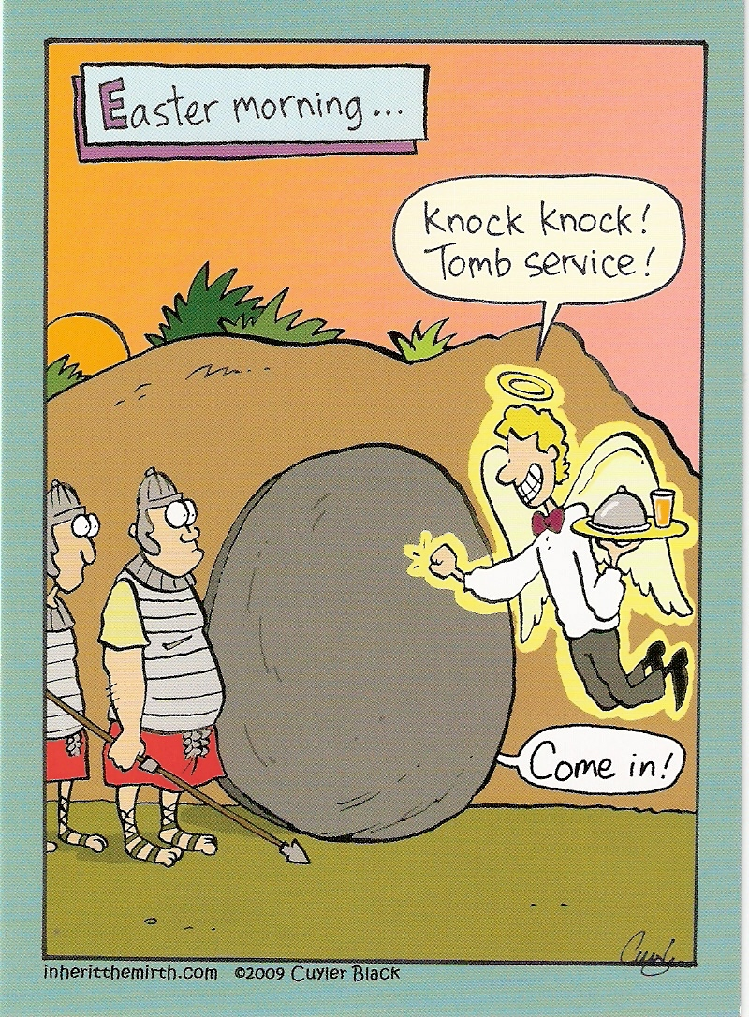
Just For Fun
Answer to Bible Quiz Time
1,000 Philistine men – Judges 15:15-16.
Illness and Prayer Concerns
Dave Bowman, Krista’s neighbor, recovering from a fall.
Chuck George’s, bladder surgery recovery.
Bob Manor, Terri Georges’ dad, covid & fluid on the brain.
Roger Curtis, back surgery recovery.
Nancy Shaffer – Colleen’s mom, fractured hip recovery.
Denny Jo Kuntz – Colleen’s sister, melanoma spot.
Mary Banks, Ginger’s mom, valve replacement recovery.
Pat Back, neuropathy will be having testing.
Bob & Phylis, Glenn’s sis & Brother-in-law, various issues.
Dennis Mount, neuropathy in feet and legs.
Health Issues: Ginger Back, Glenn Brose, Elizabeth Noel,
Carolyn Wood, Clyde Wood, Debbie Turner,
Jenny Gano Tumbleson
General Poor Health: Dylan, Kay Grills, Grant Hall,
Faith Horner, Dennis & Cheryl Irwin, Barbara Milner,
Mickey Salisbury, Norman Vincent
Migraines: Marlene Hayslip, Dale Schraw, Debbie Turner
Stomach: Mona Greer, Jim Jordan, Katie Mount
Knees: Ginger Back, Pat Back, Judy Mason, Debbie Turner
Shoulder issues: Glenn Brose
Back: Marlene Hayslip, Betty Mount, Retta Short
Kidneys: Ben Back, Marie Brooks, Glenn Brose, Henry Stevens
Cardiac: Charlene Back, Kim Banks, JR Banks,
Mary Banks, Dwayne Carl, Deneen Ervin, Steven Elliott,
Bob Fleming, Bob Jones, Brayden O’Malley, Bobby Rhoades
Cancer: Donnie Banks, Cheyanne, Chris Baker,
Glenn Gentry, Alicia Georgeff, Ken Little, Lester,
Angie Orr, Tony Rizzo, Bob Scott, Aralyn Slack,
Bob Stephens
MS: Susan Binkley (Paul’s cousin)
Personal Struggles: Cheryl Miller
Life Struggles: Ian Niehaus, Roger Curtis, Steve Jordan
Unchanging God
Malachi 3:6 – ⁶For I the LORD do not change; therefore you, O children of Jacob, are not consumed.

- SOME CHANGE
  - COMMUNICATION
HEBREWS 1:1-2 – ¹Long ago, at many times and in many ways, God spoke to our fathers by the prophets, ²but in these last days He has spoken to us by His Son, whom He appointed the heir of all things, through whom also he created the world.
_________________________________________________________

  - PLANS
EXODUS 32:14 – ¹⁴And the LORD relented from the disaster that He had spoken of bringing on His people.
_________________________________________________________

2 KINGS 20:1-6 - God changes His mind concerning Hezekiah.
_______________________________________________________

  - WORSHIP
    - PRIESTS
HEBREWS 7:23-24 – ²³The former priests were many in number, because they were prevented by death from continuing in office, ²⁴but He holds His priesthood permanently, because He continues forever.
________________________________________________________

    - SACRIFICES
HEBREWS 7:27 – ²⁷He has no need, like those high priests, to offer sacrifices daily, first for His own sins and then for those of the people, since He did this once for all when He offered up Himself.
_________________________________________________________

    - PLACE
EXODUS 23:13 – ¹⁷Three times in the year shall all your males appear before the Lord GOD. ______________________________________

- UNCHANGING NATURE
  - IMMORTAL
JOHN 1:1 — ¹In the beginning was the Word, and the Word was with God, and the Word was God._________________________________

HEBREWS 13:8 – ⁸Jesus Christ is the same yesterday and today and forever. __________________________________________________

  - PERFECT
PSALM 18:30 – ³⁰This God—his way is perfect; the word of the LORD proves true; he is a shield for all those who take refuge in him.
_______________________________________________________

  - POWER
PSALM 62:11 – ¹¹Once God has spoken; twice have I heard this: that power belongs to God. _________________________________________________________

- UNCHANGING CHARACTER
  - MERCIFUL
Deuteronomy 4:31 – ³¹For the LORD your God is a merciful God. He will not leave you or destroy you or forget the covenant with your fathers that he swore to them. _______________________________

  - LOVING
PSALM 118:12 – ¹²Let Israel say, “His steadfast love endures forever.” _______________________________________________

  - FAITHFUL
HEBREWS 6:17-18 – ¹⁷So when God desired to show more convincingly to the heirs of the promise the unchangeable character of his purpose, he guaranteed it with an oath, ¹⁸so that by two unchangeable things, in which it is impossible for God to lie, we who have fled for refuge might have strong encouragement to hold fast to the hope set before us.
______________________________________________________________

