Those Privileged to Serve   Today         Next Sunday

(Subject to change please check each Sunday morning)

Song Leader ………………  Paul Carpenter … Nate Stice

Opening Prayer ………..       Paul Carpenter …. Nate Stice

Scripture Reading ………..  Jerry Runk ….. Gary Niehaus

(Philippians 3:1-16)

Lord’s Table (Talk & Prayers) . Gary Niehaus … Dennis Mount

Closing Prayer …………… Glenn Brose …. Paul Carpenter

Announcements ………….  Glenn Brose … Paul Carpenter

Greeters ……………… Paul & Angela … Nate & Kendra

Communion Preparation for May …………....  Colleen

Birthdays May

Fred Keidel 5/3 Judy Mason 5/4

Martha Jacobs 5/21

Anniversaries May

Mel & Fay Lamb 5/24

Re-Birthdays May

 Weekly Budget   –   $1,250

Bible Correspondence Course and Home Bible Studies are available upon request.

Event room available for parties, meetings, or

other gatherings.

Call Gary Niehaus, [513-519-5783](tel:513-519-5783), for information and booking.

Pearl Street

Church Of Christ

330 Pearl Street, PO Box 380

Lynchburg, Ohio 45142

[937-579-5025](tel:937-579-5025)

[WWW.pearlstchurchofchrist.com](http://www.pearlstreetchurchofchrist.com/)

WWW.Pearlstreetcofc@gmail.com

Facebook @ Pearl Street church of Christ

Sunday Services

Bible Class ………..…………………..  9:30 AM

AM Worship …….…………………… 10:30 AM

PM Worship ..………………………….. 6:00 PM

Wednesday Service

Bible Study ……………………………….. 6:00 PM

Minister …………… Paul Carpenter ([513-375-9992](tel:513-375-9992))

May 18, 2025

Power of the Resurrection

Philippians 3:10

Welcome

Welcome to services at the Pearl Street church of Christ. If you are a visitor, know that you are an honored guest. You are invited to join us every time we come together for worship or for Bible study. If you have any questions about God, Jesus, Holy Spirit, Bible, Christianity, the worship service, or the church of Christ in general we would love to study with you to answer those questions.

Just A Thought

“No matter how devastating our struggles, disappointments, and troubles are, they are only temporary. No matter what happens to you, no matter the depth of tragedy or pain you face, no matter how death stalks you and your loved ones, the Resurrection promises you a future of immeasurable good.”

John Piper

Weekly Memory Verse

EXODUS 20:4 – 4You shall not make for yourself a carved image, or any likeness of anything that is in heaven above, or that is in the earth beneath, or that is in the water under the earth.

Bible Quiz Time

According to the book of Ezra, when was work finished on the house of the Lord in Jerusalem?

Today’s Bible Text

PHILIPPIANS 3:10; English Standard Version

10That I may know Him and the power of His resurrection, and may share Hs sufferings, becoming like Him in His death.

Paul’s Portion

There was a sense of urgency as the two men ran towards their destination. They had heard the words with their ears. They had attempted to comprehend the news with their minds. Now they ran to see it with their eyes, and their feet couldn’t get them there fast enough. Mary Magdalene informed Peter and (It is presumed) John that the body of Jesus is not in the tomb. Upon hearing the news both men go to the tomb, running as they went. When John reaches the tomb he stops outside, choosing to look inside before venturing in. (John 20:1-5) Many people have wondered why John stopped outside of the tomb. Ideas range from him wanting to give Peter the chance to enter first to his being concerned about Jewish cleanliness laws and everything in between. What if the reason John paused before going into the tomb was because he was deep in thought? As he and Peter were running to the tomb his mind must have been racing as well. Thoughts as well as questions were banging around in John’s mind. One very likely question was whether or not he could have or should have done more when Jesus was arrested, tried, and crucified. The Gospel accounts state that when Jesus was arrested all of the disciples fled. John must not have fled too far, for John 18 verses 15 and 16 mention that John followed the mob as they took Jesus away. More than just following John was able to go into the courtyard of the High Priest. Scripture states that this was possible since John was known to the High Priest. Perhaps now John is wondering if he should have used that relationship to at least speak on Jesus’ behalf. Instead, he, apparently, remained silent in the background. Then Scripture records that later John was at the foot of the cross, John 19:26-27. As John thinks back on this he may again have wondered if he could or should have done more. John undoubtedly heard Jesus cry that He was thirsty, yet someone else offered up the sponge. These thoughts may have plagued John delaying him from venturing into the tomb. Do not let your doubts about whether you have done enough in the past keep you from doing what you still can do in the present.

Take Note

Get Healthy class Tuesday evenings 6:00.

Please provide your opinion and suggestion for the best

evening for optimum participation as we begin to show

the new season of “The Chosen”.

Kamp Dovetail is seeking people to sponsor campers. Forms

can be found on the entry table.

Saturday June 28th the Pricetown Church of Christ will be

hosting a “meal-packing event” for Lifeline Christian

Mission. See flyer for information.

FYI: The weekly bulletin is available on the website.

Plan Ahead and Mark Your Calendars

(Dates are subject to change)

Due to the Village Memorial Day celebration the Fellowship

meal for May will be June 1st.

We will have regular Sunday evening Bible study May 25.

Men’s retreat at Fort Hill, May 30-31.

Due to an extra fellowship meal in June there will not be a

Song Service for the month of June.

The next Ladies Night Out will be Tuesday, June 3rd.

The next Men’s Breakfast will be June 7th, at 8 AM.

VBS will be June 16-19.

Traveling

Janet, Dennis, Colleen, Nate, and Kendra will all be returning home.

Answer to Bible Quiz Time

On the third day of the month of Adar, in the sixth year of the reign of Darius the king, Ezra 6:15.

Illness and Prayer Concerns

Shannon Woodcock, continued eye improvements.

Toni Mount, positive results from treatment.

Nate Stice, issues with his spine.

Mark DeLeonardis, esophageal cancer.

William Brose, health issues.

Todd Miller, coworker of Joyce, brain tumor surgery.

Terry McGinnis, & Jerry Harter, cancer.

Kassidy Abney, gall bladder issues.

Ralph, Mary’s brother, serious health issues.

Ginger Back, recovering from knee surgery.

Pat Back, leg and feet pain.

Glenn Brose, kidneys and gall bladder.

John Bowman, Brittany’s dad, mental anguish.

Kari Bowman, Brittany’s aunt, cancer.

Paul Michaelson, Carol’s brother, cardiac concerns.

Retta Short, success with pain pump for her back.

Todd & Carol, working through issues.

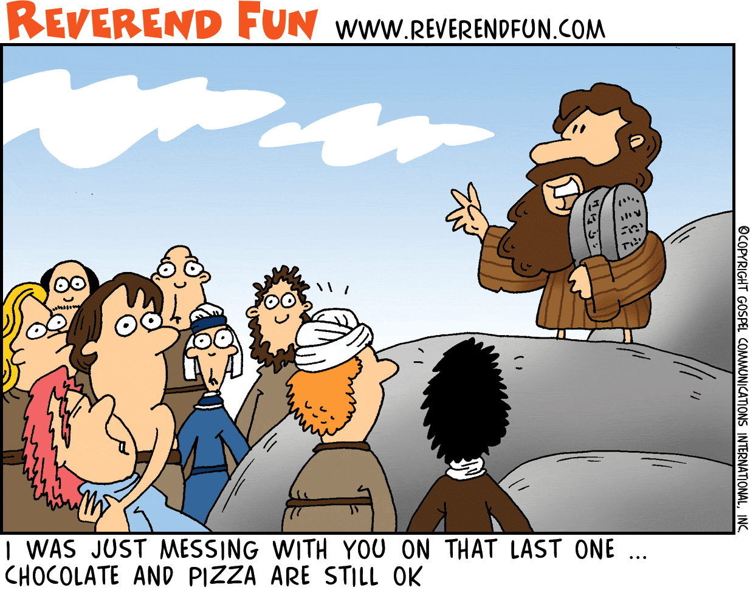Just For Fun

Power of the Resurrection

Philippians 3:10

1. HIS RESURRECTION
   1. THREE DAY REST

MATTHEW 12:38-40 – … 40For just as Jonah was three days and three nights in the belly of the great fish, so will the Son of Man be three days and three nights in the heart of the earth. _____________________________________

LUKE 24:5-7 – 5… the men said to them, “Why do you seek the living among the dead? 6He is not here, but has risen. Remember how He told you, while He was still in Galilee, 7that the Son of Man must be delivered into the hands of sinful men and be crucified and on the third day rise.” ______________________________________

* 1. CONQUERED DEATH

2 TIMOTHY 1:10 – 10and which now has been manifested through the appearing of our Savior Christ Jesus, who abolished death and brought life and immortality to light through the gospel.

_________________________________________________________

* 1. OPENED DOOR

1 CORINTHIANS 15:20-21 – 20But in fact Christ has been raised from the dead, the firstfruits of those who have fallen asleep. 21For as by a man came death, by a man has come also the resurrection of the dead. ___________________________________________________

1. POWER
   1. DYNAMITE

ROMANS 1:16 – 16For I am not ashamed of the gospel, for it is the power of God for salvation to everyone who believes, to the Jew first and also to the Greek. ______________________________________

* 1. PURPOSE

2 CORINTHIANS 5:14-15 – 14For the love of Christ controls us, because we have concluded this: that one has died for all, therefore all have died; 15and He died for all, that those who live might no longer live for themselves but for Him who for their sake died and was raised.

_________________________________________________________

* 1. CONFIDENCE

ACTS 4:33 – 33And with great power the apostles were giving their testimony to the resurrection of the Lord Jesus, and great grace was upon them all. _____________________________________________

1. NEW LIFE
   1. BY SAME POWER

ROMANS 8:9-11 – 9You, however, are not in the flesh but in the Spirit, if in fact the Spirit of God dwells in you. Anyone who does not have the Spirit of Christ does not belong to Him. 10But if Christ is in you, although the body is dead because of sin, the Spirit is life because of righteousness. 11If the Spirit of Him who raised Jesus from the dead dwells in you, He who raised Christ Jesus from the dead will also give life to your mortal bodies through His Spirit who dwells in you.

________________________________________________________

* 1. NEW PRIORITIES

PHILIPPIANS 3:7-11 – 7But whatever gain I had, I counted as loss for the sake of Christ 8Indeed, I count everything as loss because of the surpassing worth of knowing Christ Jesus my Lord. For His sake I have suffered the loss of all things and count them as rubbish, in order that I may gain Christ … 10that I may know Him and the power of His resurrection, and may share His sufferings, becoming like Him in His death, 11that by any means possible I may attain the resurrection from the dead. ________________________________________________

* 1. POWER OVER SIN

ROMANS 6:12-14 – 12Let not sin therefore reign in your mortal body, to make you obey its passions. …14For sin will have no dominion over you, since you are not under law but under grace.

_________________________________________________________

ROMANS 6:1-4 – 1What shall we say then? Are we to continue in sin that grace may abound? 2By no means! How can we who died to sin still live in it? 3Do you not know that all of us who have been baptized into Christ Jesus were baptized into His death? 4We were buried therefore with Him by baptism into death, in order that, just as Christ was raised from the dead by the glory of the Father, we too might walk in newness of life.  ________________________________________