Those Privileged to Serve   Today         Next Sunday

(Subject to change please check each Sunday morning)

Song Leader ………………  Nate Stice .…. Dennis Mount

Opening Prayer ………..       Nate Stice ….. Dennis Mount

Scripture Reading ………..  Gary Niehaus .. Paul Carpenter

(MATTHEW 11:28-30)

Lord’s Table (Talk & Prayers) . Dennis Mount …. Nate Stice

Closing Prayer …………… Paul Carpenter .. Gary Niehaus

Announcements ………….  Paul Carpenter .. Gary Niehaus

Greeters ……………… Nate & Kendra . Dennis & Colleen

Communion Preparation for June …………....  Kendra

Birthdays May/June

Fred Keidel 5/3 Judy Mason 5/4

Martha Jacobs 5/21

Ginger Back 6/26 Shannon Woodcock 6/9

Anniversaries May/June

Mel & Fay Lamb 5/24

Glenn & Mary 6/6

Re-Birthdays May/June

Faith Carpenter 6/23 Colleen Mount 6/22

Tracey Runk 6/12

 Weekly Budget   –   $1,250

Bible Correspondence Course and Home Bible Studies are available upon request.

Event room available for parties, meetings, or

other gatherings.

Call Gary Niehaus, [513-519-5783](tel:513-519-5783), for information and booking.

Pearl Street

Church Of Christ

330 Pearl Street, PO Box 380

Lynchburg, Ohio 45142

[937-579-5025](tel:937-579-5025)

[WWW.pearlstchurchofchrist.com](http://www.pearlstreetchurchofchrist.com/)

WWW.Pearlstreetcofc@gmail.com

Facebook @ Pearl Street church of Christ

Sunday Services

Bible Class ………..…………………..  9:30 AM

AM Worship …….…………………… 10:30 AM

PM Worship ..………………………….. 6:00 PM

Wednesday Service

Bible Study ……………………………….. 6:00 PM

Minister …………… Paul Carpenter ([513-375-9992](tel:513-375-9992))

May 25, 2025

Share the Yoke

Matthew 11:28-30

Welcome

Welcome to services at the Pearl Street church of Christ. If you are a visitor, know that you are an honored guest. You are invited to join us every time we come together for worship or for Bible study. If you have any questions about God, Jesus, Holy Spirit, Bible, Christianity, the worship service, or the church of Christ in general we would love to study with you to answer those questions.

Just A Thought

In Matthew 11:28 Jesus is setting Himself apart from everyone and everything they had previously known.

“The I is emphasized in the Greek. He gives what no one else can give—rest from the burden of sin, from the weariness of fruitless toil.”

Ellicott’s Commentary for English Readers

Weekly Memory Verse

EXODUS 20:7 – 7You shall not take the name of the LORD your God in vain, for the LORD will not hold Him guiltless who takes His name in vain.

Bible Quiz Time

How long had the women Jesus healed in the Synagogue, had the disabling spirit which caused her to be bent over?

Today’s Bible Text

MATTHEW 11:29; English Standard Version

29Take my yoke upon you, and learn from me, for I am gentle and lowly in heart, and you will find rest for your souls.

Paul’s Portion

When Peter heard the report from Mary he didn’t believe her. It is not that he thought she was lying, rather he believed her to be suffering from delusions, hallucinations, or maybe simple confusion. Mary had seemed somewhat hysterical when she relayed her message that “They have taken the Lord out of the tomb, and we do not know where they have laid Him”. (John 20:2) Now Peter is running to the tomb to see for Himself if his Lord’s tomb had been desecrated. Perhaps he was blaming himself for what had happened. Maybe he questioned if he had let Jesus down again? His mind no doubt went to the night three days ago when he denied Jesus, not once or twice, but three times in the matter of minutes. As Peter ran and remembered he probably thought back to how Jesus had turned and looked at him as the rooster crowed. (Luke 22:61) Peter must have felt that he had let Jesus down, after he had so vehemently stated that he would never deny Jesus. (Matthew 26:33-35) As Peter shamefully recalled his failings and Jesus looking at him, he may have thought “He was so dejected as I denied Him those three times.” Hearing that Jesus’ body had been taken from the tomb Peter may now be thinking that He had let Jesus down once again. Peter was perhaps thinking that he should have been vigilant at the tomb. Instead, he was hiding with the others which allowed someone to take Jesus’ body away. Peter arrives at the tomb, and he sees that the Lord’s body is indeed missing. It doesn’t, however, have the signs of mischief, foul play, or blasphemy. The grave clothes were lying there with the face cloth neatly folded and lying near by. Peter goes from the tomb puzzled still wondering how things might have been different if he had vigilantly stood by his Messiah through the arrest, trial, crucifixion and burial. Thankfully for Peter his confusion was alleviated when Jesus revealed Himself to the disciples in the upper room. (John 20:19) Peter’s shame was alleviated with Jesus’ obvious forgiveness. (John 21:15-19) Have you felt shame due to feeling you have let Jesus down? You can know that Jesus forgives and loves you and alleviates your shame when you ask Him.

Take Note

Please provide your opinion and suggestion for the best

evening for optimum participation as we begin to show

the new season of “The Chosen”.

Kamp Dovetail is seeking people to sponsor campers. Forms

can be found on the entry table.

Saturday June 28th the Pricetown Church of Christ will be

hosting a “meal-packing event” for Lifeline Christian

Mission. See flyer for information.

The new “Our Daily Bread” is available.

FYI: The weekly bulletin is available on the website.

Plan Ahead and Mark Your Calendars

(Dates are subject to change)

The village of Lynchburg is holding a Memorial Day

“Parade” and observance today starting at noon.

Due to the Village Memorial Day observance the Fellowship

meal for May will be June 1st.

We will have regular Sunday evening Bible study tonight.

Men’s retreat at Fort Hill, May 30-31.

Get Healthy class Tuesday evenings 6:00.

Due to an extra fellowship meal in June there will not be a

Song Service for the month of June.

The next Ladies Night Out will be Tuesday, June 3rd.

The next Men’s Breakfast will be June 7th, at 8 AM.

VBS will be June 16-19.

Traveling

Mel & Fay are camping this weekend.

Answer to Bible Quiz Time

Eighteen years, LUKE 13:11, 16.

Illness and Prayer Concerns

Diana Carl, kidneys.

Eldon Carl, surgery on June 21.

Shannon Woodcock, continued eye improvements.

Toni Mount, positive results from treatment.

Nate Stice, issues with his spine.

Mark DeLeonardis, esophageal cancer.

William Brose, health issues.

Todd Miller, coworker of Joyce, brain tumor surgery.

Terry McGinnis, & Jerry Harter, cancer.

Ralph, Mary’s brother, serious health issues.

Pat Back, leg and feet pain.

Glenn Brose, kidneys and gall bladder.

John Bowman, Brittany’s dad, mental anguish.

Kari Bowman, Brittany’s aunt, cancer.

Retta Short, success with pain pump for her back.

Todd & Carol, working through issues.

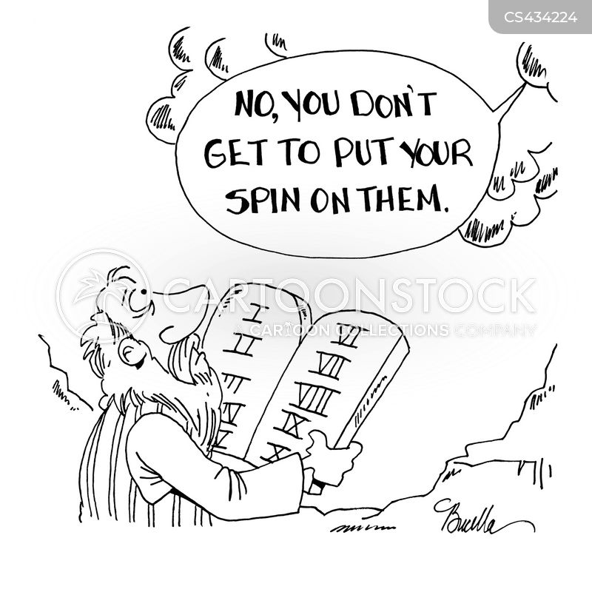Just For Fun

Share the Yoke

Matthew 11:28-30 – 28Come to me, all who labor and are heavy laden, and I will give you rest. 29Take my yoke upon you, and learn from me, for I am gentle and lowly in heart, and you will find rest for your souls. 30For my yoke is easy, and my burden is light.”

1. THE YOKE
   1. TOOL

A yoke is a wooden beam that is sometimes used between a pair of oxen or other animals to help them work together when pulling a load.

_________________________________________________________

* 1. SYMBOL

Can mean slavery, oppression, punishment; LEVITICUS 26:13, DEUTERONOMY 28:48, 1 KINGS 12:4.

_________________________________________________________

* 1. PERSONAL

Not the same as taking up your cross, LUKE 9:23.

__________________________________________________________

1. JESUS YOKE
   1. SHARED

Come unto me. To be yoked together you have to be side by side.

* 1. RIGHT YOKE

2 CORINTHIANS 6:14-15 – 14Do not be unequally yoked with unbelievers. For what partnership has righteousness with lawlessness? Or what fellowship has light with darkness? 15What accord has Christ with Belial? Or what portion does a believer share with an unbeliever?

_________________________________________________________

DEUTERONOMY 22:10 – 10You shall not plow with an ox and a donkey together. ___________________________________________

GALATIANS 5:1 – 1For freedom Christ has set us free; stand firm therefore, and do not submit again to a yoke of slavery.

_________________________________________________________

* 1. LEARNING

1 PETER 2:21 – 21For to this you have been called, because Christ also suffered for you, leaving you an example, so that you might follow in His steps. _______________________________________________

1 JOHN 2:6 – 6whoever says he abides in Him ought to walk in the same way in which He walked._______________________________

1. FIND REST
   1. YOKE EASY

MATTHEW 23:4 – 4They tie up heavy burdens, hard to bear, and lay them on people’s shoulders, but they themselves are not willing to move them with their finger. ________________________________

* 1. BURDEN LIGHT

Yoke of Jesus is not the same as taking up your cross.Luke 9:23.

___________________________________________________

1 JOHN 5:3 – 3For this is the love of God, that we keep His commandments. And His commandments are not burdensome.

_______________________________________________________

PSALM 119: 35 – 35Lead me in the path of your commandments, for I delight in it. ______________________________________________

* 1. REST

HEBREWS 4:9-10 – 9So then, there remains a Sabbath rest for the people of God, 10for whoever has entered God’s rest has also rested from his works as God did from His. __________________________

1 JOHN 1:7 – 7But if we walk in the light, as He is in the light, we have fellowship with one another, and the blood of Jesus His Son cleanses us from all sin. _________________________________