Those Privileged to Serve   Today         Next Sunday

(Subject to change please check each Sunday morning)

Song Leader ………………  Nate Stice …. Dennis Mount

Opening Prayer ………..       Nate Stice …. Dennis Mount

Scripture Reading ………..  Paul Carpenter . Glenn Bose

(EPHESIANS 4:1-6)

Lord’s Table (Talk & Prayers) . Glenn Brose …. Nate Stice

Closing Prayer …………… Dennis Mount .. Jerry Runk

Announcements ………….  Dennis Mount .. Jerry Runk

Greeters ……………… Dennis & Colleen .. Glenn & Mary

Communion Preparation for May …………....  Colleen

Birthdays May

Fred Keidel 5/3 Judy Mason 5/4

Martha Jacobs 5/21

Anniversaries May

Mel & Fay Lamb 5/24

Re-Birthdays May

 Weekly Budget   –   $1,250

Bible Correspondence Course and Home Bible Studies are available upon request.

Event room available for parties, meetings, or

other gatherings.

Call Gary Niehaus, [513-519-5783](tel:513-519-5783), for information and booking.

Pearl Street

Church Of Christ

330 Pearl Street, PO Box 380

Lynchburg, Ohio 45142

[937-579-5025](tel:937-579-5025)

[WWW.pearlstchurchofchrist.com](http://www.pearlstreetchurchofchrist.com/)

WWW.Pearlstreetcofc@gmail.com

Facebook @ Pearl Street church of Christ

Sunday Services

Bible Class ………..…………………..  9:30 AM

AM Worship …….…………………… 10:30 AM

PM Worship ..………………………….. 6:00 PM

Wednesday Service

Bible Study ……………………………….. 6:00 PM

Minister …………… Paul Carpenter ([513-375-9992](tel:513-375-9992))

May 4, 2025

Being Relevant to God

Romans 12:2

Welcome

Welcome to services at the Pearl Street church of Christ. If you are a visitor, know that you are an honored guest. You are invited to join us every time we come together for worship or for Bible study. If you have any questions about God, Jesus, Holy Spirit, Bible, Christianity, the worship service, or the church of Christ in general we would love to study with you to answer those questions.

Just A Thought

“We need to find God, and he cannot be found in noise and restlessness. God is the friend of silence. See how nature – trees, flowers, grass- grows in silence; see the stars, the moon and the sun, how they move in silence… We need silence to be able to touch souls.” – Agnes Gonxha Bojaxhiu

“Be still, and know that I am God. I will be exalted among the nations, I will be exalted in the earth!” Psalm 46:10.

Weekly Memory Verse

EXODUS 20:2 – 2I am the LORD your God, who brought you out of the land of Egypt, out of the house of slavery.

Bible Quiz Time

Moses’ father-in-law, Jethro was called the priest of _______

Today’s Bible Text

ROMANS 12:2; English Standard Version

2Do not be conformed to this world, but be transformed by the renewal of your mind, that by testing you may discern what is the will of God, what is good and acceptable and perfect.

Paul’s Portion

How often do people ask themselves, “Did I make the right choice?” Some may ask this after making a menu choice, a college choice, a job choice, even a mate choice. On that Resurrection Sunday when the women walked to the tomb it is possible that at least one of the women was struggling with this question. Very little is known about this woman, she being mentioned by name in only two verses, Luke 8:3 and Luke 24:10. This woman was Joanna. In the Hebrew Joanna’s name means “Yahweh has been gracious,” if she believed this it may explain her becoming a follower of Jesus. It is learned from Luke 8:2 that Joanna was healed by Jesus. This does beg the question, however, of how she came to be healed. Did she happen upon Jesus as He was teaching, or did she seek Him out. Luke does tell us that she was the wife of Chuza, Herod’s household manager, Chuza controlled Herod’s treasury and property. This being the case she would have been part of Herod’s court and possibly would have been exposed to John the baptizer’s teaching. This then would have introduced her to Jesus. Believing her name and what she heard of Jesus might have caused her to seek Him out for her healing. She now would have been in a difficult spot. To be a follower of Jesus would not have been a favorable position in the court of Herod. To be associated with Herod’s court would not have been a favorable position amongst the Jews. Joanna decided it was worth the risk to go to Jesus. After her healing she was so convinced of Jesus and His ministry that she became a follower. This means that she had to step away from her comfort, wealth, privilege, and husband at least on occasion. Now as Joanna is walking to the tomb she may be asking herself if she made the right choice in following Jesus. Through her choice she has possibly spent all her money, become estranged from her husband, and lost her prominent standing. Any such questioning would have vanished when the women met Jesus in the garden.  Joanna realized that she did indeed make the right choice. When we stand face to face with Jesus will we realize that out choice was right or wrong?

Take Note

Tonight is our monthly Song Service, please join us.

Due to Ladies Nite Out the Get Healthy class will not meet.

FYI: The weekly bulletin is available on the website.

Plan Ahead and Mark Your Calendars

(Dates are subject to change)

The next Ladies Night Out will be this Tuesday, May 6th.

Men’s retreat at Fort Hill, May 30-31.

Due to the Village Memorial Day celebration the Fellowship

meal for May will be June 1st.

We will have regular Sunday evening Bible study May 25.

Due to an extra fellowship meal in June there will not be a

Song Service for the month of June.

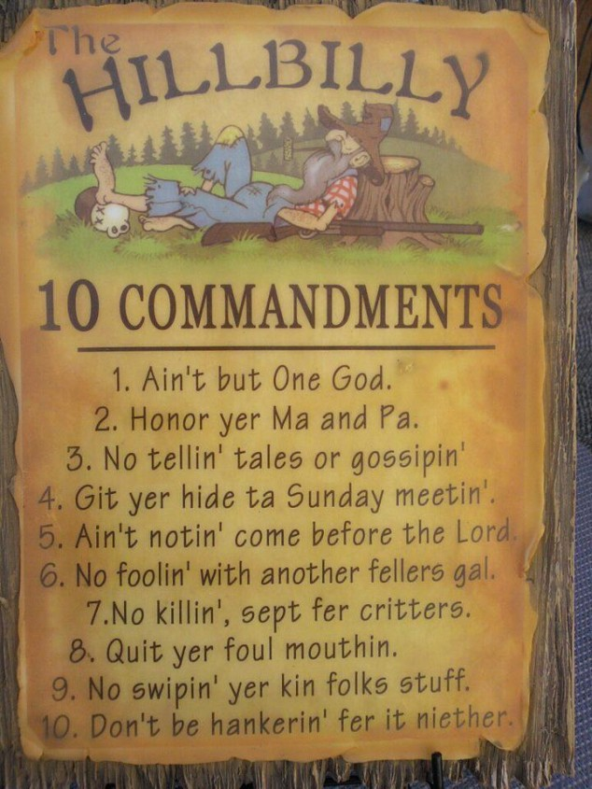Just For Fun

Answer to Bible Quiz Time

Jethro was called the priest of Midian, EXODUS 18:1.

Illness and Prayer Concerns

Shannon Woodcock, continued eye improvements.

Toni Mount, going to W.V. for treatment.

Nate Stice, issues with his spine.

Mark DeLeonardis, esophageal cancer.

William Brose, health issues.

Mark Curfman, in ICU due to bad reaction to meds.

Greg Shepherd, recovery from hip surgery.

Martha’s sister Pinkie, recovering from hip surgery, strokes.

Todd Miller, coworker of Joyce, brain tumor surgery.

Terry McGinnis, & Jerry Harter, cancer.

Kassidy Abney, gall bladder issues.

Ralph, Mary’s brother, serious health issues.

Ginger Back, recovering from knee surgery.

Pat Back, leg and feet pain.

Fay Lamb, success of completed radiation treatment.

Glenn Brose, kidneys and gall bladder.

John Bowman, Brittany’s dad, mental anguish.

Kari Bowman, Brittany’s aunt, cancer.

Paul Michaelson, Carol’s brother, cardiac concerns.

Retta Short, success with pain pump for her back.

Paul & Patty Jarret, health issues.

Todd & Carol, working through issues.

Sympathy

Condolences to loved ones of Ron Wise in his passing.

Traveling

Carol will be returning home.

Habitat for Humanity

Habitat for Humanity is still seeking a property and family for their next build. See Dennis with questions.

Being Relevant to God

ROMANS 12:2

1. BELIEVE
   1. IN HIM

HEBREWS 11:6 – 6And without faith it is impossible to please Him, for whoever would draw near to God must believe that He exists and that He rewards those who seek Him.

_________________________________________________________

* 1. IN WORD

2 PETER 1:21 – 21For no prophecy was ever produced by the will of man, but men spoke from God as they were carried along by the Holy Spirit. ___________________________________________________

HEBREWS 4:12 – 12For the word of God is living and active, sharper than any two-edged sword, piercing to the division of soul and of spirit, of joints and of marrow, and discerning the thoughts and intentions of the heart. ______________________________________

* 1. ACKNOWLEDGE

JAMES 2:19 – 19You believe that God is one; you do well. Even the demons believe—and shudder! _______________________________

REVELATION 4:11 – 11“Worthy are you, our Lord and God, to receive glory and honor and power, for you created all things, and by your will they existed and were created.”

________________________________________________________

PROVERBS 3:5-6 – 5Trust in the LORD with all your heart, and do not lean on your own understanding. 6In all your ways acknowledge Him, and He will make straight your paths.

______________________________________________________

1. OBEY
   1. HIS WORD

JOHN 14:15 – 15If you love me, you will keep my commandments.

_____________________________________________________

1 JOHN 5:3 – 3For this is the love of God, that we keep His commandments. And His commandments are not burdensome.

______________________________________________________

* 1. LOVE

MATTHEW 22:37-40 – 37…  “You shall love the Lord your God with all your heart and with all your soul and with all your mind.  38This is the great and first commandment.  39And a second is like it: You shall love your neighbor as yourself. … _____________________________

* 1. FORGIVE

MATTHEW 6:14-15 – 14For if you forgive others their trespasses, your heavenly Father will also forgive you, 15but if you do not forgive others their trespasses, neither will your Father forgive your trespasses.

_________________________________________________________

1 JOHN 1:9 – 9If we confess our sins, He is faithful and just to forgive us our sins and to cleanse us from all unrighteousness.

________________________________________________________

* 1. PRAY

2 CHRONICLES 7:14 – 14if my people who are called by my name humble themselves, and pray and seek my face and turn from their wicked ways, then I will hear from heaven and will forgive their sin and heal their land. ________________________________________

LUKE 18:1-18 – 18And He told them a parable to the effect that they ought always to pray and not lose heart. … Persistent widow.

_________________________________________________________

1. REPRESENT
   1. THROUGH OBEDIENCE

ROMANS 16:19 – 19For your obedience is known to all, so that I rejoice over you, … _____________________________________

* 1. THROUGH BOLDNESS

ACTS 4:13 – The boldness of Peter and John exhibited that they had been with Jesus.__________________________________________

ACTS 19:8 – Paul boldly entered the synagogue. __________________________________________________

* 1. THROUGH LOVE

JOHN 13:35 – 35By this all people will know that you are my disciples, if you have love for one another.”

_______________________________________________________