Those Privileged to Serve   Today         Next Sunday

(Subject to change please check each Sunday morning)

Song Leader ………………  Dennis Mount …. Nate Stice

Opening Prayer ………..       Dennis Mount ... Nate Stice

Scripture Reading ………..  Paul Carpenter …. Jerry Runk

(LUKE 7:11-17)

Lord’s Table (Talk & Prayers) . Nate Stice .……. Glenn Brose

Closing Prayer …………… Gary Niehaus … Paul Carpenter

Announcements ………….  Gary Niehaus ... Paul Carpenter

Greeters ……………… Dennis & Colleen .. Paul & Angela

Communion Preparation for June …………....  Kendra

Birthdays June

Ginger Back 6/26 Shannon Woodcock 6/9

Anniversaries June

Glenn & Mary 6/6

Re-Birthdays June

Faith Carpenter 6/23 Colleen Mount 6/22

Tracey Runk 6/12

 Weekly Budget   –   $1,250

Bible Correspondence Course and Home Bible Studies are available upon request.

Event room available for parties, meetings, or

other gatherings.

Call Gary Niehaus, [513-519-5783](tel:513-519-5783), for information and booking.

Pearl Street

Church Of Christ

330 Pearl Street, PO Box 380

Lynchburg, Ohio 45142

[937-579-5025](tel:937-579-5025)

[WWW.pearlstchurchofchrist.com](http://www.pearlstreetchurchofchrist.com/)

WWW.Pearlstreetcofc@gmail.com

Facebook @ Pearl Street church of Christ

Sunday Services

Bible Class ………..…………………..  9:30 AM

AM Worship …….…………………… 10:30 AM

PM Worship ..………………………….. 6:00 PM

Wednesday Service

Bible Study ……………………………….. 6:00 PM

Minister …………… Paul Carpenter ([513-375-9992](tel:513-375-9992))

June 1, 2025

Touch

LUKE 7:11-17

Welcome

Welcome to services at the Pearl Street church of Christ. If you are a visitor, know that you are an honored guest. You are invited to join us every time we come together for worship or for Bible study. If you have any questions about God, Jesus, Holy Spirit, Bible, Christianity, the worship service, or the church of Christ in general we would love to study with you to answer those questions.

Just A Thought

Sometimes all it takes is a touch to make a huge difference and impact on a person’s life. Jesus demonstrated this fact numerous times in Scripture.

“The power of touch in the Bible is a multifaceted theme that reveals God's desire to connect with humanity in a personal and transformative way. Through touch, blessings are imparted, healing is administered, and lives are changed, reflecting the profound love and power of God.”

“Power of Touch” Biblehub.com

Weekly Memory Verse

EXODUS 20:8 – 8Remember the Sabbath day, to keep it holy.

Bible Quiz Time

Who were Aaron’s (Moses’ brother) sons?

Today’s Bible Text

LUKE 7:14; English Standard Version

14Then He came up and touched the bier, and the bearers stood still. And He said, “Young man, I say to you, arise.”

Paul’s Portion

The story of Daniel in the lion’s den has been a Sunday School staple for generations. Naturally, one point that is taught is the fact that Daniel stayed true to his faith refusing to give in to the King’s edict, even though he knew it would bring punishment. This segues nicely into a lesson on how God watches over His people protecting them in even the most drastic of situations. Sometimes when this story is taught the emphasis is placed on the Satraps, and high officials as a lesson on jealousy, greed, and manipulation. When the story of Daniel and the lion’s den is told it behooves one to also address the king. Darius was the king at this time. It was Darius who was manipulated by the officials. It was Darius who let his pride and ego direct his actions. It was Darius who threw Daniel in the den of lions. It was then Darius who expected God to fix the mess. In chapter 6 of Daniel verse 16 it is recorded that Darius said, “May your God, whom you serve continually, deliver you”. Then in the morning he rushes to the den and cries out, “O Daniel, servant of the living God, has your God, whom you serve continually, been able to deliver you from the lions?” Daniel 6:20. Before this it states that Darius was distressed about Daniel’s punishment trying to find a solution, verse 14. It also records in verse 18 that Darius spent a sleepless night in fasting. It is argued, based on verse 15, that Darius’s hands were tied. Even if the edict could not be changed, it seems Darius could have done something. Instead, Darius sealed the entrance closed and left Daniel to rely on his God. Basically, Darius got himself and Daniel into a mess and expected God to bail them out. This sounds very familiar. People have been getting themselves into trouble and expecting God to bail them out since time began. Like Darius, even those who are not believers will call on God to get them out of their messes. The phenomenal point is that God does bail us out of our messes. This is not to say that He always will, but He does way more often than we deserve. So, do your best to live right in God’s sight, but when you get yourself into a mess don’t hesitate to call on Him.

Take Note

This afternoon we will be having a meal followed by trip to

the Commons.

Please provide your opinion and suggestion for the best

evening for optimum participation as we begin to show

the new season of “The Chosen”.

Kamp Dovetail is seeking people to sponsor campers. Forms

can be found on the entry table.

Saturday June 28th the Pricetown Church of Christ will be

hosting a “meal-packing event” for Lifeline Christian

Mission. See flyer for information.

The new “Our Daily Bread” is available.

FYI: The weekly bulletin is available on the website.

Plan Ahead and Mark Your Calendars

(Dates are subject to change)

Get Healthy class Tuesday evenings 6:00. (Not this week).

Due to an extra fellowship meal in June there will not be a

Song Service for the month of June.

The next Ladies Night Out will be Tuesday, June 3rd.

The Men’s Breakfast has been moved to June 14th, at 8 AM.

VBS is TWO WEEKS AWAY, June 16-19.

Sympathy

Our sympathy is extended to the families of Maggie Samples and Phil Hawkins, two young people from Harding who were killed in a car accident.

Traveling

Dennis and Colleen are heading to Alabama.

Answer to Bible Quiz Time

Nadab and Abihu, Eleazar and Ithamar, Exodus 28:1.

Illness and Prayer Concerns

Patty Kiedell, broken ankle.

Brittany Nesmith, thyroid issues.

Diana Carl, kidneys.

Eldon Carl, surgery on June 21.

Shannon Woodcock, continued eye improvements.

Toni Mount, positive results from treatment.

William Brose, health issues.

Todd Miller, coworker of Joyce, brain tumor surgery.

Paul & Patty Jarret, bronchitis.

Ralph, Mary’s brother, serious health issues.

Pat Back, leg and feet pain.

Glenn Brose, kidneys and gall bladder.

John Bowman, Brittany’s dad, mental anguish.

Kari Bowman, Brittany’s aunt, cancer.

Retta Short, success with pain pump for her back.

Todd & Carol, working through issues.

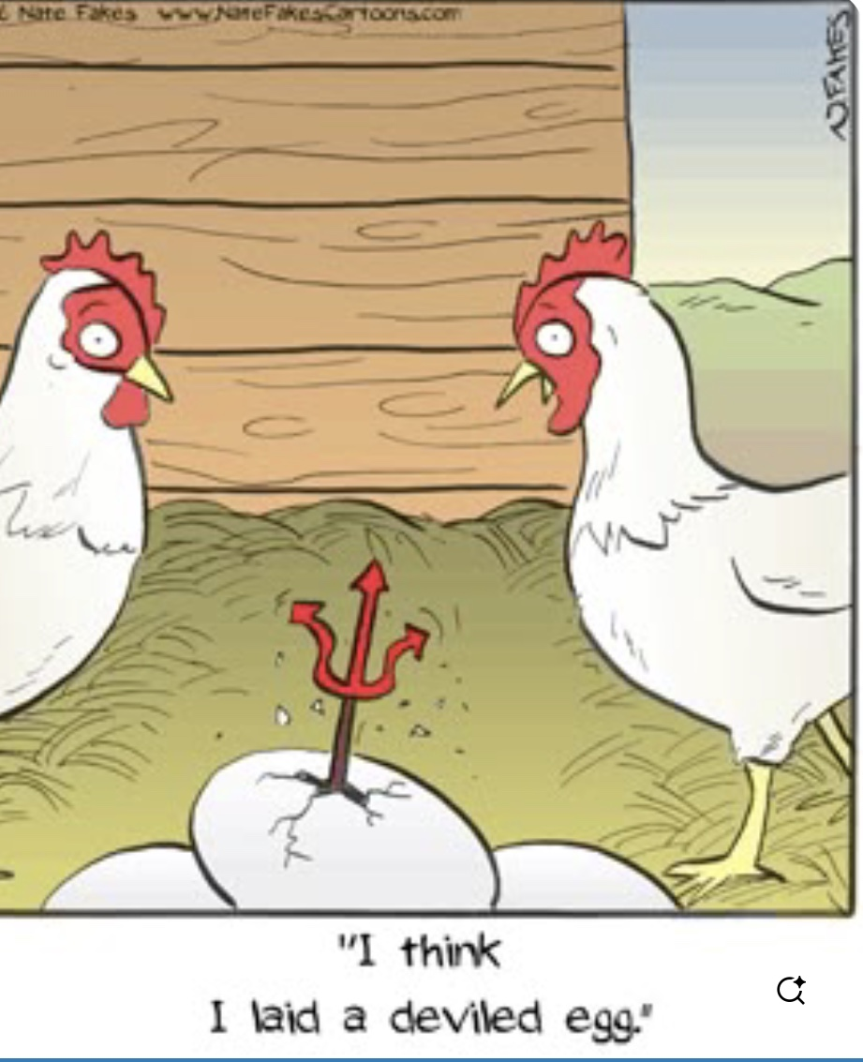Just For Fun

Touch

LUKE 7:11-17 – 11Soon afterward He went to a town called Nain, and His disciples and a great crowd went with Him. 12As He drew near to the gate of the town, behold, a man who had died was being carried out, the only son of his mother, and she was a widow, and a considerable crowd from the town was with her. 13And when the Lord saw her, He had compassion on her and said to her, “Do not weep.”  14Then He came up and touched the bier, and the bearers stood still. And H e said, “Young man, I say to you, arise.” 15And the dead man sat up and began to speak, and Jesus gave him to his mother. 16Fear seized them all, and they glorified God, saying, “A great prophet has arisen among us!” and “God has visited His people!” 17And this report about Him spread through the whole of Judea and all the surrounding country.

1. UNEXPECTED
   1. SCENE OBSERVED

LUKE 7:11-12 – 11Soon afterward He went to a town called Nain, and His disciples and a great crowd went with Him. 12As He drew near to the gate of the town, behold, a man who had died was being carried out, the only son of his mother, and she was a widow, and a considerable crowd from the town was with her.

_________________________________________________________

* 1. JESUS ACTS

LUKE 7:13-14 – 13And when the Lord saw her, He had compassion on her and said to her, “Do not weep.”  14Then He came up and touched the bier, and the bearers stood still. And H e said, “Young man, I say to you, arise.”

_________________________________________________________

* 1. RISKY

NUMBERS 19:11-13 – 11Whoever touches the dead body of any person shall be unclean seven days. 12He shall cleanse himself with the water on the third day and on the seventh day, and so be clean. But if he does not cleanse himself on the third day and on the seventh day, he will not become clean. 13Whoever touches a dead person, the body of anyone who has died, and does not cleanse himself, defiles the tabernacle of the LORD, and that person shall be cut off from Israel; because the water for impurity was not thrown on him, he shall be unclean. His uncleanness is still on him.

_________________________________________________________

1. HEARTFELT
   1. NO AGENDA

_________________________________________________________

* 1. HAD COMPASSION

LUKE 7:13 – 13And when the Lord saw her, He had compassion on her and said to her, “Do not weep.”

_________________________________________________________

1. IMPACTFUL
   1. DEAD RAISED

LUKE 7:15 – 15And the dead man sat up and began to speak, and Jesus gave him to his mother.

_________________________________________________________

* 1. CROWD AMAZED

LUKE 7:16 – 16Fear seized them all, and they glorified God, saying, “A great prophet has arisen among us!” and “God has visited His people!”

_________________________________________________________

* 1. WORD SPREAD

LUKE 7:17 – 17And this report about Him spread through the whole of Judea and all the surrounding country.

_________________________________________________________