Those Privileged to Serve   Today         Next Sunday

(Subject to change please check each Sunday morning)

Song Leader ……………… Dennis Mount … Dennis Mount

Opening Prayer ………..      Dennis Mount .. Dennis Mount

Scripture Reading ………..  Glenn Brose …. Gary Niehaus

(EXODUS 16:12-36)

Lord’s Table (Talk & Prayers) . Nate Stice ….. Paul Carpenter

Closing Prayer …………… Gary Niehaus …. Glenn Brose

Announcements ………….  Gary Niehaus …. Glenn Brose

Greeters ……………… Nate & Kendra .. Glenn & Mary

Communion Preparation for June …………....  Kendra

Birthdays June

Ginger Back 6/26 Shannon Woodcock 6/9

Anniversaries June

Glenn & Mary 6/6

Re-Birthdays June

Faith Carpenter 6/23 Colleen Mount 6/22

Tracey Runk 6/12

 Weekly Budget   –   $1,250

Bible Correspondence Course and Home Bible Studies are available upon request.

Event room available for parties, meetings, or

other gatherings.

Call Gary Niehaus, [513-519-5783](tel:513-519-5783), for information and booking.

Pearl Street

Church Of Christ

330 Pearl Street, PO Box 380

Lynchburg, Ohio 45142

[937-579-5025](tel:937-579-5025)

[WWW.pearlstchurchofchrist.com](http://www.pearlstreetchurchofchrist.com/)

WWW.Pearlstreetcofc@gmail.com

Facebook @ Pearl Street church of Christ

Sunday Services

Bible Class ………..…………………..  9:30 AM

AM Worship …….…………………… 10:30 AM

PM Worship ..………………………….. 6:00 PM

Wednesday Service

Bible Study ……………………………….. 6:00 PM

Minister …………… Paul Carpenter ([513-375-9992](tel:513-375-9992))

June 15, 2025

Taste

Psalm 34:8

Welcome

Welcome to services at the Pearl Street church of Christ. If you are a visitor, know that you are an honored guest. You are invited to join us every time we come together for worship or for Bible study. If you have any questions about God, Jesus, Holy Spirit, Bible, Christianity, the worship service, or the church of Christ in general we would love to study with you to answer those questions.

Just A Thought

“In the Bible, the five senses serve as vital conduits through which individuals can experience and understand the divine. Sight, hearing, taste, touch, and smell are not merely physical faculties; they are also spiritual tools that facilitate a deeper connection with God. For instance, seeing the beauty of creation can lead to a greater appreciation of God’s artistry, while hearing the Word of God can inspire faith and obedience. Each sense invites believers to engage with their surroundings in a way that reflects God’s presence and purpose.” “What the Bible Says About the Five Senses”; Godsbless.ing

Weekly Memory Verse

EXODUS 20:13 – 13You shall not murder.

Bible Quiz Time

How did God punish the Israelites when they complained about their food?

Today’s Bible Text

PSALM 34:8; English Standard Version

8Oh, taste and see that the LORD is good! Blessed is the man who takes refuge in him!

Paul’s Portion

When “taste this” is offered the response is often influenced by the one making the offer. If it is a trusted loved one that is asking or suggesting to “taste this” the probability of actually tasting is much higher than if it is a stranger or untrustworthy person. There is a degree of trust involved when acting on the request to “taste this.” A piece of advice is to never blindly taste what is offered to you if it is offered on the first of April. There are basically three reasons why someone would invite another to taste something. It could be as a joke. The one offering knows that it tastes bad and wants to see a reaction. It could be that the one offering is seeking an opinion on the taste. It could be that the one offering wants to share the gustatory experience. When this is the case the one who invites another to taste something is not wanting the person to merely put a dab on the tongue. Rather the invitation is to take a full bite and perhaps hold it in the mouth for a bit so as to truly experience the fullness of flavors. Everyone has seen a person gulp down their food without really chewing it. Many cooks have lamented over the fact that they spend hours in the kitchen preparing a delicious meal only to have it devoured in a matter of minutes. To taste one needs to slow down the eating process. Each bite should be savored allowing the various spices and flavors to activate the appropriate taste buds, whether sweet, savory, or bitter. In the act of eating too fast flavors are missed. The Psalmist, David, is inviting his readers to taste and see that the Lord is good, Psalm 34:8. The idea behind David’s words is not that people would sample the Lord, but that they would truly and fully experience Him. For one to understand the meaning of the eighth verse of Psalm 34 one needs to look at the whole verse. To taste the Lord and to take refuge in the Lord are connected. To taste the Lord is to take the time to experience the Lord. To taste the Lord means to experience the bold aspects of who and what the Lord is, but also to appreciate the delicate and sometimes subtle nuances as well. There is much to taste with the Lord. Take your time and appreciate all of the divine flavors.

Take Note

Vacation Bible Schools begins tomorrow night at 6PM and

runs through Thursday night. There will be classes for

children, Grades K-5. We will also have an Adult class.

We could still use some volunteers to assist with Vacation

Bible school. Please see Paul if you can assist at all.

Please provide your opinion and suggestion for the best

evening for optimum participation as we begin to show

the new season of “The Chosen”.

Kamp Dovetail is seeking people to sponsor campers. Forms

can be found on the entry table.

Saturday June 28th the Pricetown Church of Christ will be

hosting a “meal-packing event” for Lifeline Christian

Mission. See flyer for information.

The new “Our Daily Bread” is available.

FYI: The weekly bulletin is available on the website.

Plan Ahead and Mark Your Calendars

(Dates are subject to change)

Get Healthy class Tuesday evenings 6:00.

Our next fellowship meal will be June 29th.

The next Ladies Night Out will be Tuesday, July 1st.

Our next song service will be July 6th.

The next Men’s Breakfast will be Saturday July 5th.

Traveling

Nate & Kendra going to Florida.

Answer to Bible Quiz Time

The LORD sent fiery serpents among the people, and they bit the people, so that many people of Israel died, NUMBERS 21:6.

Illness and Prayer Concerns

Jim Fields, injures from a fall.

Patty Kiedell, broken ankle.

Brittany Nesmith, thyroid issues.

Diana Carl, kidneys.

Eldon Carl, surgery on June 21.

Shannon Woodcock, continued eye improvements.

Toni Mount, positive results from treatment.

William Brose, health issues.

Jim Limback, friend of Carol and Angela, pancreatitis.

Todd Miller, coworker of Joyce, brain tumor surgery.

Ralph, Mary’s brother, serious health issues.

Pat Back, leg and feet pain.

John Bowman, Brittany’s dad, mental anguish.

Kari Bowman, Brittany’s aunt, cancer.

Retta Short, success with pain pump for her back.

Doug Carpenter, Paul’s cousin, cardiac issues.

Todd & Carol, working through issues.

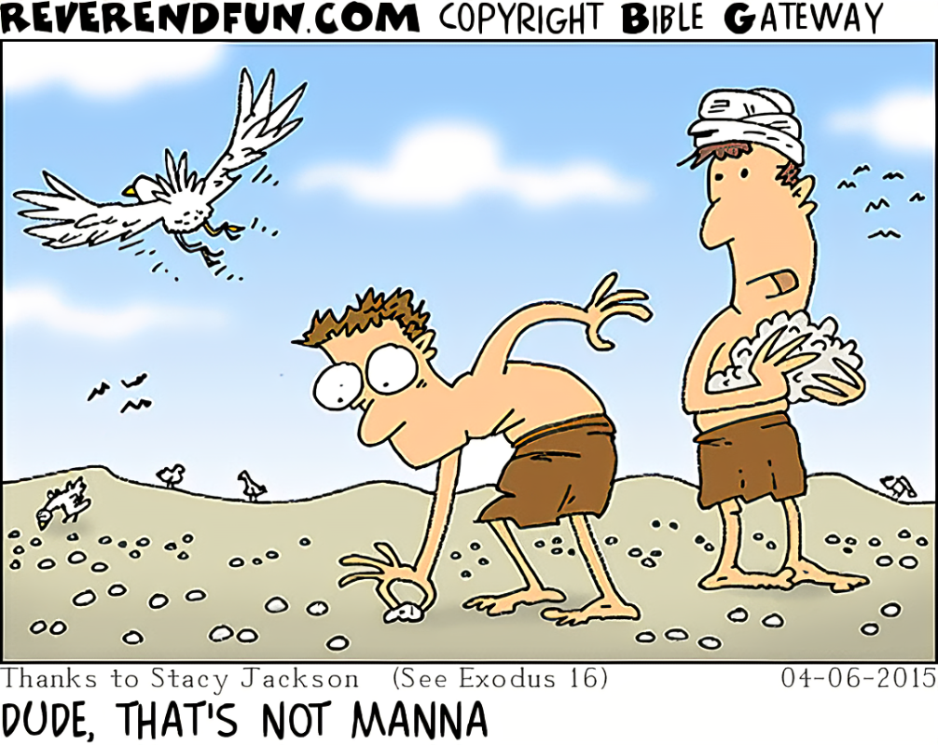Just For Fun

Taste

Psalm 34:8

1. MADE TO TASTE
   1. TASTE BUDS

PSALM 139:13-14 – 13For you formed my inward parts; you knitted me together in my mother’s womb. 14I praise you, for I am fearfully and wonderfully made. Wonderful are your works; my soul knows it very well.

_________________________________________________________

* 1. PURPOSEFUL FLAVOR
     1. MANNA

EXODUS 16:31 – 31Now the house of Israel called its name manna. It was like coriander seed, white, and the taste of it was like wafers made with honey.

_________________________________________________________

NUMBERS 11:7-8 – 7Now the manna was like coriander seed, and its appearance like that of bdellium. 8The people went about and gathered it and ground it in handmills or beat it in mortars and boiled it in pots and made cakes of it. And the taste of it was like the taste of cakes baked with oil.

_________________________________________________________

* + 1. WINE

JOHN 2:9-10 – 9When the master of the feast tasted the water now become wine, and did not know where it came from (though the servants who had drawn the water knew), the master of the feast called the bridegroom 10and said to him, “Everyone serves the good wine first, and when people have drunk freely, then the poor wine. But you have kept the good wine until now.”

________________________________________________________

1. SPIRITUAL TASTE
   1. TASTE LORD

Psalm 34:8 – 8Oh, taste and see that the LORD is good! Blessed is the man who takes refuge in Him! _______________________________

1 PETER 2:2-3 – 2Like newborn infants, long for the pure spiritual milk, that by it you may grow up into salvation— 3if indeed you have tasted that the Lord is good. _________________________________

* 1. TASTE WORD

PSALM 119:103 – 103How sweet are your words to my taste, sweeter than honey to my mouth! ___________________________________

1. JESUS TASTE TESTER
   1. TASTED DEATH

HEBREWS 2:9 – 9But we see Him who for a little while was made lower than the angels, namely Jesus, crowned with glory and honor because of the suffering of death, so that by the grace of God He might taste death for everyone. ____________________________________

JOHN 8:52 – 52The Jews said to Him, “Now we know that you have a demon! Abraham died, as did the prophets, yet you say, ‘If anyone keeps my word, he will never taste death.’

_________________________________________________________

* 1. DON’T LOSE TASTE

HEBREWS 6:4-6 – 4For it is impossible, in the case of those who have once been enlightened, who have tasted the heavenly gift, and have shared in the Holy Spirit, 5and have tasted the goodness of the word of God and the powers of the age to come, 6and then have fallen away, to restore them again to repentance, since they are crucifying once again the Son of God to their own harm and holding Him up to contempt.

______________________________________________________