Those Privileged to Serve   Today         Next Sunday

(Subject to change please check each Sunday morning)

Song Leader ……………… Dennis Mount .…. Nate Stice

Opening Prayer ………..      Dennis Mount …. Nate Stice

Scripture Reading ………..  Gary Niehaus … Dennis Mount

(MATTHEW 13:9-23)

Lord’s Table (Talk & Prayers) . Paul Carpenter … Gary Niehaus

Closing Prayer …………… Glenn Brose .…. Jerry Runk

Announcements ………….  Glenn Brose ….. Jerry Runk

Greeters ……………… Glenn & Mary …. Paul & Angela

Communion Preparation for June …………....  Kendra

Birthdays June

Ginger Back 6/26 Shannon Woodcock 6/9

Anniversaries June

Glenn & Mary 6/6

Re-Birthdays June

Faith Carpenter 6/23 Colleen Mount 6/22

Tracey Runk 6/12

 Weekly Budget   –   $1,250

Bible Correspondence Course and Home Bible Studies are available upon request.

Event room available for parties, meetings, or

other gatherings.

Call Gary Niehaus, [513-519-5783](tel:513-519-5783), for information and booking.

Pearl Street

Church Of Christ

330 Pearl Street, PO Box 380

Lynchburg, Ohio 45142

[937-579-5025](tel:937-579-5025)

[WWW.pearlstchurchofchrist.com](http://www.pearlstreetchurchofchrist.com/)

WWW.Pearlstreetcofc@gmail.com

Facebook @ Pearl Street church of Christ

Sunday Services

Bible Class ………..…………………..  9:30 AM

AM Worship …….…………………… 10:30 AM

PM Worship ..………………………….. 6:00 PM

Wednesday Service

Bible Study ……………………………….. 6:00 PM

Minister …………… Paul Carpenter ([513-375-9992](tel:513-375-9992))

June 22, 2025

Hear

Romans10:17

Welcome

Welcome to services at the Pearl Street church of Christ. If you are a visitor, know that you are an honored guest. You are invited to join us every time we come together for worship or for Bible study. If you have any questions about God, Jesus, Holy Spirit, Bible, Christianity, the worship service, or the church of Christ in general we would love to study with you to answer those questions.

Just A Thought

“To listen fully means to pay close attention to what is being said beneath the words. You listen not only to the 'music,' but to the essence of the person speaking. You listen not only for what someone knows, but for what he or she is. Ears operate at the speed of sound, which is far slower than the speed of light the eyes take in. Generative listening is the art of developing deeper silences in yourself, so you can slow our mind's hearing to your ears' natural speed, and hear beneath the words to their meaning.”

Author Peter Senge

Weekly Memory Verse

EXODUS 20:14 – 13You shall not commit adultery.

Bible Quiz Time

How many angels did Jesus say His Father could send and rescue Him if He asked?

Today’s Bible Text

ROMANS 10:17; English Standard Version

17So faith comes from hearing, and hearing through the word of Christ.

Paul’s Portion

There are certain foods and drinks that people only eat on certain days or seasons of the year for instance, eggnog, fruitcake, marshmallow peeps, black-eyed peas, corn beef & cabbage, pumpkin spice, etc. These foods and drinks are available throughout the year. Most people, however, only consume them for a short space of time during the year. What is the rationale for this behavior? Does egg-nog only taste good when drinking it at Christmas time? Are black-eyed peas only edible on New Year Day? Is there a rule that corn beef and cabbage can any be prepared for St. Patrick’s Day? Arguably, peeps do have a limited appeal time, but for most of the “seasonal” foods partaking of them throughout the year is fine. It is not just foods that are boxed into certain times of the year. Try blasting Christmas music in the middle of August and notice people’s reaction. Why can’t we go on a hayride in the middle of June instead of it always being in the fall. Imagine the pandemonium that would ensue if there was an egg hunt at Thanksgiving. Traditions bear the brunt of the blame for regulating foods, activities, etc to certain times. The real problem is when traditions dictate times for Spiritual partaking. Many people pray when they wake up, when they go to sleep and before meals and that is it, because of tradition. The Bible tells us to pray without ceasing, 1 Thessalonians 5:17. For many people singing hymns is limited to the worship service, but the Scriptures are loaded with references to singing outside of services. Similarly, for many people reading the Bible is a nighttime occurrence. The Bible encourages more than a tradition based regime of Bible reading. When reading verses such as 2 Timothy 3:16-17, 1 Peter 2:2 and others it is obvious that Bible reading should occur often throughout the day. Then there is the act of worship itself. For many, worship is limited to that hour or so on Sunday mornings. The book of Acts shows us that worship took place in different times and different places. Paul and Silas worshipped in prison at midnight, Acts 16:25. If you want to only have egg nog at Christmas fine, but give God His due at all times.

Take Note

Thank you to everyone who assisted with or attended

Vacation Bible School this past week. It’s time now for

follow up.

Thank you, also, to those who went out and assisted with

serving breakfast at Kamp Dovetail Friday morning.

Please provide your opinion and suggestion for the best

evening for optimum participation as we begin to show

the new season of “The Chosen”.

Saturday June 28th the Pricetown Church of Christ will be

hosting a “meal-packing event” for Lifeline Christian

Mission. See flyer for information.

The new “Our Daily Bread” is available.

FYI: The weekly bulletin is available on the website.

Plan Ahead and Mark Your Calendars

(Dates are subject to change)

Get Healthy class Tuesday evenings 6:00.

Our next fellowship meal will be next Sunday, June 29th.

The next Ladies Night Out will be Tuesday, July 1st.

Our next song service will be July 6th.

The next Men’s Breakfast will be Saturday July 5th.

Traveling

Nate & Kendra going to Florida.

Extended Mount clan coming to Lynchburg for July 4th.

Answer to Bible Quiz Time

More than 12 legions, Matthew 26:53. Legions consisted of 5,000 – 6,000 men.

Illness and Prayer Concerns

Jim Fields, injures from a fall.

Patty Kiedell, broken ankle.

Brittany Nesmith, thyroid issues.

Diana Carl, kidneys.

Eldon Carl, surgery on June 21.

Shannon Woodcock, continued eye improvements.

Toni Mount, positive results from treatment.

William Brose, health issues.

Jim Limback, friend of Carol and Angela, pancreatitis.

Todd Miller, coworker of Joyce, brain tumor surgery.

Ralph, Mary’s brother, serious health issues.

Pat Back, leg and feet pain.

John Bowman, Brittany’s dad, mental anguish.

Kari Bowman, Brittany’s aunt, cancer.

Retta Short, success with pain pump for her back.

Doug Carpenter, Paul’s cousin, cardiac issues.

Todd & Carol, working through issues.

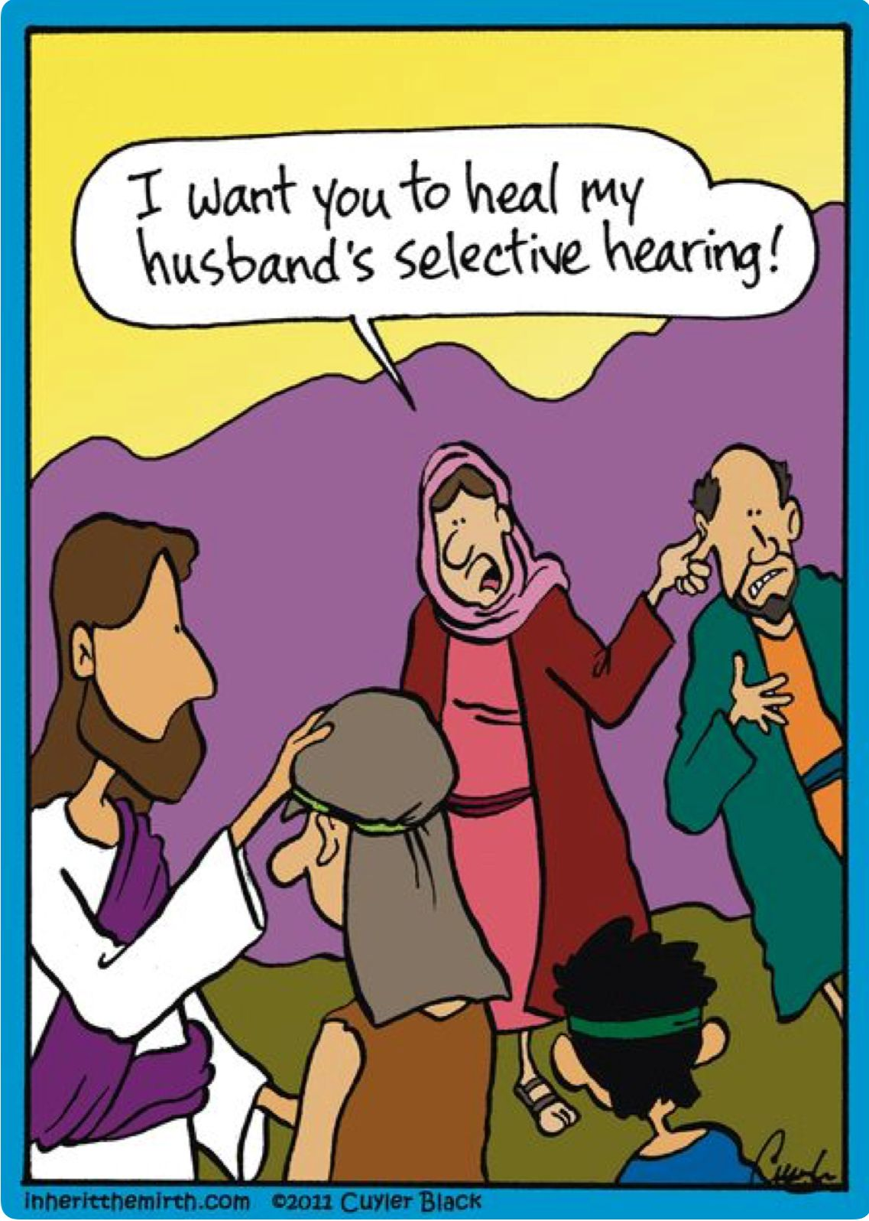Just For Fun

Hear

Romans10:17

1. GIFT OF HEARING
   1. GOD GIVEN
   2. JESUS HEALED

MARK 7:32-35 – 32And they brought to him a man who was deaf and had a speech impediment, and they begged him to lay his hand on him. 33And taking him aside from the crowd privately, he put his fingers into his ears, and after spitting touched his tongue. 34And looking up to heaven, he sighed and said to him, “Ephphatha,” that is, “Be opened.” 35And his ears were opened, his tongue was released, and he spoke plainly. __________________________________________________

ISAIAH 35:5 – 5Then the eyes of the blind shall be opened, and the ears of the deaf unstopped. ___________________________________

1. ACT OF HEARING
   1. USE

MATTHEW 13:9 – 9He who has ears, let him hear.”

_________________________________________________________

* 1. WISELY

JAMES 1:19 – 19 Know this, my beloved brothers: let every person be quick to hear, slow to speak, slow to anger.

_________________________________________________________

* 1. DISCERNING

1 KINGS 19:12 – 12And after the earthquake a fire, but the LORD was not in the fire. And after the fire the sound of a low whisper.

________________________________________________________

JOHN 10:3, 27 – 3To him the gatekeeper opens. The sheep hear his voice, and he calls his own sheep by name and leads them out. … 27My sheep hear my voice, and I know them, and they follow me.

________________________________________________________

1. RESPONSIBILITY OF HEARING
   1. UNDERSTANDING

MATTHEW 13:13 – 13This is why I speak to them in parables, because seeing they do not see, and hearing they do not hear, nor do they understand. ___________________________________________

MATTHEW 13:16 – 16But blessed are your eyes, for they see, and your ears, for they hear. _____________________________________

MATTHEW 13:23 – 23As for what was sown on good soil, this is the one who hears the word and understands it. __________________________________________________

* 1. BELIEF

ROMANS 10:14-17 – 14How then will they call on him in whom they have not believed? And how are they to believe in him of whom they have never heard? And how are they to hear without someone preaching? … 17So faith comes from hearing, and hearing through the word of Christ. ____________________________________________

HEBREWS 2:1-4 – 1Therefore we must pay much closer attention to what we have heard, lest we drift away from it.

_________________________________________________________

* 1. ACTION

James 1:22-25 – 22 But be doers of the word, and not hearers only, deceiving yourselves. ______________________________________

MATTHEW 7:24-27 – 24Everyone then who hears these words of mine and does them will be like a wise man who built his house on the rock. … 26And everyone who hears these words of mine and does not do them will be like a foolish man who built his house on the sand.

_________________________________________________________