Those Privileged to Serve Today Next Sunday
(Subject to change please check each Sunday morning)
Song Leader ……………… Nate Stice .…. Dennis Mount
Opening Prayer ……….. Nate Stice .…. Dennis Mount
Scripture Reading ……….. Jerry Runk ……. Nate Stice
(1 PETER 3:8-17)
Lord’s Table (Talk & Prayers) . Paul Carpenter … Glenn Brose
Closing Prayer …………… Glenn Brose …. Jerry Runk
Announcements …………. Glenn Brose …. Jerry Runk
Greeters ……………… Nate & Kendra ….. Glenn & Mary
Communion Preparation for July ………….... Joyce

Birthdays July
Retta Short 7/1 Kendra Stice 7/28

Anniversaries July

Re-Birthdays July
Mary Brose 7/7 Jerry Runk 7/19
Nate Stice 7/29 Kendra Stice 7/29

Weekly Budget – $1,250

Bible Correspondence Course and Home Bible Studies are available upon request.

Event room available for parties, meetings, or
other gatherings.

Call Gary Niehaus, 513-519-5783, for information and booking.

Pearl Street
Church Of Christ

330 Pearl Street, PO Box 380
Lynchburg, Ohio 45142
937-579-5025
WWW.pearlstchurchofchrist.com
WWW.Pearlstreetcofc@gmail.com
Facebook @ Pearl Street church of Christ

Sunday Services
Bible Class ………..………………….. 9:30 AM
AM Worship …….…………………… 10:30 AM
PM Worship ..………………………….. 6:00 PM

Wednesday Service
Bible Study ……………………………….. 6:00 PM

Minister …………… Paul Carpenter (513-375-9992)

July 13, 2025
Freedom From Guilt
Hebrews 13:18

Welcome
Welcome to services at the Pearl Street church of Christ. If you are a visitor, know that you are an honored guest. You are invited to join us every time we come together for worship or for Bible study. If you have any questions about God, Jesus, Holy Spirit, Bible, Christianity, the worship service, or the church of Christ in general we would love to study with you to answer those questions.

Just A Thought
“To the last day of your life, be positive; try to be cheerful. Even at the very end, don't think, "I am finished." Instead of pitying yourself, you should be thinking, "O ye who are left on this desolate shore still to mourn and deplore, it is I who pity you." Death will not give you any trouble if you have a clear conscience; and if you go with this thought: "Lord, I am in Thy hands.”
Paramahansa Yogananda (Not to promote him or his beliefs)

Weekly Memory Verse
EXODUS 20:17 – ¹⁷You shall not covet your neighbor’s house; you shall not covet your neighbor’s wife, or his male servant, or his female servant, or his ox, or his donkey, or anything that is your neighbor’s.

Bible Quiz Time
Who was the false god to whom the Lord forbade offering children as a sacrifice?
Today’s Bible Text
HEBREWS 13:18; English Standard Version
¹⁸Pray for us, for we are sure that we have a clear conscience, desiring to act honorably in all things.
Paul’s Portion
Jesus had to endure much in His “trial” and death. He was beaten, mocked, slandered, abused, and crucified. Although not as severe as what He endured during His death Jesus endured during His ministry as well. Of course, there were the religious leaders who regularly questioned Him and attempted to discredit Him. There were also those in the crowds who just didn’t seem to get it. One such occurrence can be seen in the Luke’s writing. Jesus is teaching the crowds about hypocrisy, having no fear, acknowledging Him before men, etc. when suddenly ¹³Someone in the crowd said to Him, “Teacher, tell my brother to divide the inheritance with me.” ¹⁴But He said to him, “Man, who made me a judge or arbitrator over you?” Luke 12:13-14. This had nothing to do with what Jesus was teaching at the time, and as Jesus pointed out, wasn’t even something for Jesus to do. This type of thing probably happened to Jesus all the time. Jesus may have wanted to say, “Can we stay on topic here”. Instead, Jesus used it as a teaching moment to instruct about true riches with the parable of the rich fool and teaching about not being anxious about things of this life. How often did Jesus get frustrated with people not listening to His teaching, but only wanting to press their agenda or desires? In this instance it may have been even more frustrating to Jesus. This man was worried about sharing the inheritance with his brother while Jesus was sharing teaching about a much greater inheritance. Jesus came to make it possible to become children of God, John 1:12. With becoming a child of God one also becomes a fellow heir with Jesus, Romans 8:17. This man was so caught up in his own petty concerns that he was missing the big picture. Why worry about a pittance from his brother when Jesus is offering abundantly more? Yet, how many are still making the same mistake that this man made? People today are still wrapped up in their concerns and issues that they are missing the real message of Jesus. By focusing on what are really minor issues, of this world, many are missing the big picture. Listen to Jesus’ message, stay on topic, and you will be enriched.
Take Note
Please provide your opinion and suggestions for the best
evening for optimum participation as we begin to show
the new season of “The Chosen”.
The Secret Sister activity is ongoing, remember your sister.
Please pick up the extended prayer list for July.
Thank you to the men who participated in the Men’s
breakfast yesterday morning. There was a change of
venue, but we had a great attendance.
FYI: The weekly bulletin is available on the website.

Plan Ahead and Mark Your Calendars
(Dates are subject to change)
Get Healthy class Tuesday evenings 6:00.
Our next fellowship meal will be Sunday, July 27th.
The next Ladies Night Out will beTuesday, August 5th.
The next Men’s Breakfast will be Saturday August 2nd.
Please provide input on our next “Worship at the Park”.

Sympathy
We send our heartfelt sympathy to Patty Kiedel and family in the passing of her sister, Gloria Norman.

Traveling
Carol will be returning home to Michigan tomorrow.

“Jesus said to them, “If you were blind, you would have no guilt; but now that you say, ‘We see,’ your guilt remains.”
John 9”41

Answer to Bible Quiz Time
Molech, Leviticus 20:1-5.
Illness and Prayer Concerns
Victims of the Texas floods.
Nate Stice, skin surgery on the 16th.
Jim Fields, injures from a fall.
Patty Kiedel, broken ankle.
Diana Carl, kidneys.
Eldon Carl, recovery from surgery.
Shannon Woodcock, continued eye improvements.
William Brose, health issues.
Jim Limback, friend of Carol and Angela, pancreatitis.
Todd Miller, coworker of Joyce, brain tumor surgery.
Ralph, Mary’s brother, serious health issues.
Pat Back, leg and feet pain.
Retta Short, success with pain pump for her back.
Doug Carpenter, recovery from heart surgery and stroke.
Pat & Ginger, comfort over their beloved pet.
Mona Greer’s niece’s boyfriend Tim, breathing issues.
Todd & Carol, working through issues.
Military: Amber Smith, Sarah King.

Just For Fun
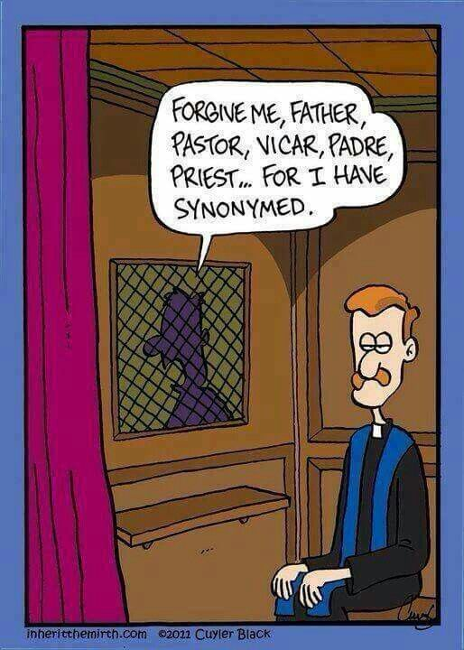

Freedom From Guilt
Hebrews 13:18 – ¹⁸Pray for us, for we are sure that we have a clear conscience, desiring to act honorably in all things.

- CLEAR CONSIENCE
  - PAUL STATES
ACTS 23:1-2 – ¹And looking intently at the council, Paul said, “Brothers, I have lived my life before God in all good conscience up to this day.” ²And the high priest Ananias commanded those who stood by him to strike him on the mouth.
_________________________________________________________
ACTS 24:16 – ¹⁶So I always take pains to have a clear conscience toward both God and man.
_________________________________________________________

  - PAUL’S PAST
1 TIMOTHY 1:12-16 – Paul was no saint when Christ saved him.
________________________________________________________

- MADE CLEAR
  - CHRIST PAID
HEBREWS 10:10 – ¹⁰And by that will we have been sanctified through the offering of the body of Jesus Christ once for all.
________________________________________________________
COLOSIANS 1:21-23 – ²¹And you, who once were alienated and hostile in mind, doing evil deeds, ²² He has now reconciled in His body of flesh by His death, in order to present you holy and blameless and above reproach before Him, ²³if indeed you continue in the faith, stable and steadfast, not shifting from the hope of the gospel that you heard, which has been proclaimed in all creation under heaven, and of which I, Paul, became a minister.
_________________________________________________________

  - BELIEVE
JOHN 3:18 – ¹⁸Whoever believes in Him is not condemned, but whoever does not believe has already been condemned, because he has not believed in the name of God’s one and only Son.
_________________________________________________________

  - WASH SELF
ACTS 22:16 – ¹⁶And now why do you wait? Rise and be baptized and wash away your sins, calling on his name.’
________________________________________________________

- KEEP CLEAR
  - WALK RIGHT
ROMANS 6:1-2 – ¹What shall we say then? Are we to continue in sin that grace may abound? ²By no means! How can we who died to sin still live in it? ____________________________________________

1 PETER 3:8-17 - Righteous conduct.
_________________________________________________________

  - AVOID WRONG
1 PETER 2:11-12 – ¹¹Beloved, I urge you as sojourners and exiles to abstain from the passions of the flesh, which wage war against your soul. ¹²Keep your conduct among the Gentiles honorable, so that when they speak against you as evildoers, they may see your good deeds and glorify God on the day of visitation.
_________________________________________________________

  - TRUST PROCESS
1 JOHN 1:7 – ⁷But if we walk in the light, as He is in the light, we have fellowship with one another, and the blood of Jesus His Son cleanses us from all sin.
________________________________________________

