Those Privileged to Serve   Today         Next Sunday

(Subject to change please check each Sunday morning)

Song Leader ………………  Dennis Mount …. Nate Stice

Opening Prayer ………..       Dennis Mount …. Nate Stice

Scripture Reading ………..  Paul Carpenter …. Jerry Runk

(MATTHEW 6:25-34)

Lord’s Table (Talk & Prayers) . Nate Stice ….. Paul Carpenter

Closing Prayer …………… Gary Niehaus …. Glenn Brose

Announcements ………….  Gary Niehaus … Glenn Brose

Greeters ……………… Dennis & Colleen . Nate & Kendra

Communion Preparation for July …………....  Joyce

Birthdays July

Retta Short 7/1 Kendra Stice 7/28

Anniversaries July

Re-Birthdays July

Mary Brose 7/7 Jerry Runk 7/19

Nate Stice 7/29 Kendra Stice 7/29

 Weekly Budget   –   $1,250

Bible Correspondence Course and Home Bible Studies are available upon request.

Event room available for parties, meetings, or

other gatherings.

Call Gary Niehaus, [513-519-5783](tel:513-519-5783), for information and booking.

Pearl Street

Church Of Christ

330 Pearl Street, PO Box 380

Lynchburg, Ohio 45142

[937-579-5025](tel:937-579-5025)

[WWW.pearlstchurchofchrist.com](http://www.pearlstreetchurchofchrist.com/)

WWW.Pearlstreetcofc@gmail.com

Facebook @ Pearl Street church of Christ

Sunday Services

Bible Class ………..…………………..  9:30 AM

AM Worship …….…………………… 10:30 AM

PM Worship ..………………………….. 6:00 PM

Wednesday Service

Bible Study ……………………………….. 6:00 PM

Minister …………… Paul Carpenter ([513-375-9992](tel:513-375-9992))

July 6, 2025

Freedom From Anxiety

1 Peter 5:7

Welcome

Welcome to services at the Pearl Street church of Christ. If you are a visitor, know that you are an honored guest. You are invited to join us every time we come together for worship or for Bible study. If you have any questions about God, Jesus, Holy Spirit, Bible, Christianity, the worship service, or the church of Christ in general we would love to study with you to answer those questions.

Just A Couple Thoughts

“A Christian's freedom from anxiety is not due to some guaranteed freedom from trouble, but to the folly of worry and especially to the confidence that God is our Father, that even permitted suffering is within the orbit of His care. John Scott

“Anxiety does not empty tomorrow of its sorrows, but only empties today of its strength.” Charles Spurgeon

Weekly Memory Verse

EXODUS 20:16 – 16You shall not bear false witness against your neighbor.

Bible Quiz Time

According to Paul’s letter to the Church at Ephesus, where is the fruit of light found?

Today’s Bible Text

1 PETER 5:7; English Standard Version

7casting all your anxieties on Him, because He cares for you.

Paul’s Portion

Many people have experienced the feeling of living paycheck to paycheck. When one lives paycheck to paycheck they constantly wonder how they will pay the next bill or buy the next groceries. When living paycheck to paycheck the slightest unexpected expense could be disastrous. With living paycheck to paycheck a car problem or medical emergency could very well mean that some other expense is neglected that month. There are different causes for one to be living paycheck to paycheck. Some find themselves living one paycheck at a time due to unexpected expenses that set them behind on their finances. Some live paycheck to paycheck due to simply not earning enough to make ends meet. Then there are those living paycheck to paycheck because they don’t budget their monies properly. This brings up another aspect of living paycheck to paycheck. The one who makes $500 a week and lives paycheck to paycheck lives a very different lifestyle then the one who makes $2000 a week and lives paycheck to paycheck. When one gets the paycheck makes a difference as well, whether it is weekly, bi-weekly, or monthly. In the Spiritual walk believers are living paycheck to paycheck as well. There are “expenses” that believers have as they go on their spiritual journey. These “expenses” are things such as faith, forgiveness, compassion, evangelism, basically following Jesus’ commands (John 14:15) Each time a believer obeys Jesus’ commands it is like taking a withdrawal from his Spiritual bank account. The more one forgives others or has a religious dialogue with others the more they deplete their Spiritual bank account. Unlike one’s physical bank account one is to draw from the Spiritual account daily. (Luke 9:23) This in essence causes the believer to live paycheck to paycheck Spiritually. The question, or questions, then become, what kind of paycheck are you getting, and how often are you getting it? Spiritual paychecks come in the form of, prayer, bible study, Christian fellowship, and the like. The bigger and the more often the Spiritual paycheck arrives the better one is able to spend that Spiritual currency in service to the Lord.

Take Note

Please provide your opinion and suggestion for the best

evening for optimum participation as we begin to show

the new season of “The Chosen”.

The Secret Sister activity is ongoing, remember your sister.

Please pick up the extended prayer list for July.

FYI: The weekly bulletin is available on the website.

Plan Ahead and Mark Your Calendars

(Dates are subject to change)

Tonight is our monthly song service, July 6th.

Get Healthy class Tuesday evenings 6:00.

Our next fellowship meal will be Sunday, July 27th.

The next Ladies Night Out will beTuesday, August 5th.

The next Men’s Breakfast will be Saturday July 12th.

Please provide input on our next “Worship at the Park”.

Sympathy

We send our heartfelt sympathy to Patty Kiedel and family in the passing of her sister, Gloria Norman.

Sympathy is extended to Cheryl Irwin and family in the passing of her mother, Pauline Arledge.

Condolences are offered to Ron Smith and family in the passing of Myrna Smith.

“Now may the Lord of peace himself give you peace at all times in every way. The Lord be with you all.”

2 Thessalonians 3:16.

Answer to Bible Quiz Time

In all that is good and right and true, Ephesians 5:9.

Illness and Prayer Concerns

Victims of the Texas floods.

Nate Stice, skin surgery on the 16th.

Jim Fields, injures from a fall.

Patty Kiedel, broken ankle.

Diana Carl, kidneys.

Eldon Carl, recovery from surgery.

Shannon Woodcock, continued eye improvements.

William Brose, health issues.

Jim Limback, friend of Carol and Angela, pancreatitis.

Todd Miller, coworker of Joyce, brain tumor surgery.

Ralph, Mary’s brother, serious health issues.

Pat Back, leg and feet pain.

Retta Short, success with pain pump for her back.

Doug Carpenter, recovery from heart surgery and stroke.

Mona Greer’s niece’s boyfriend Tim, breathing issues.

Todd & Carol, working through issues.

Military: Amber Smith, Sarah King.

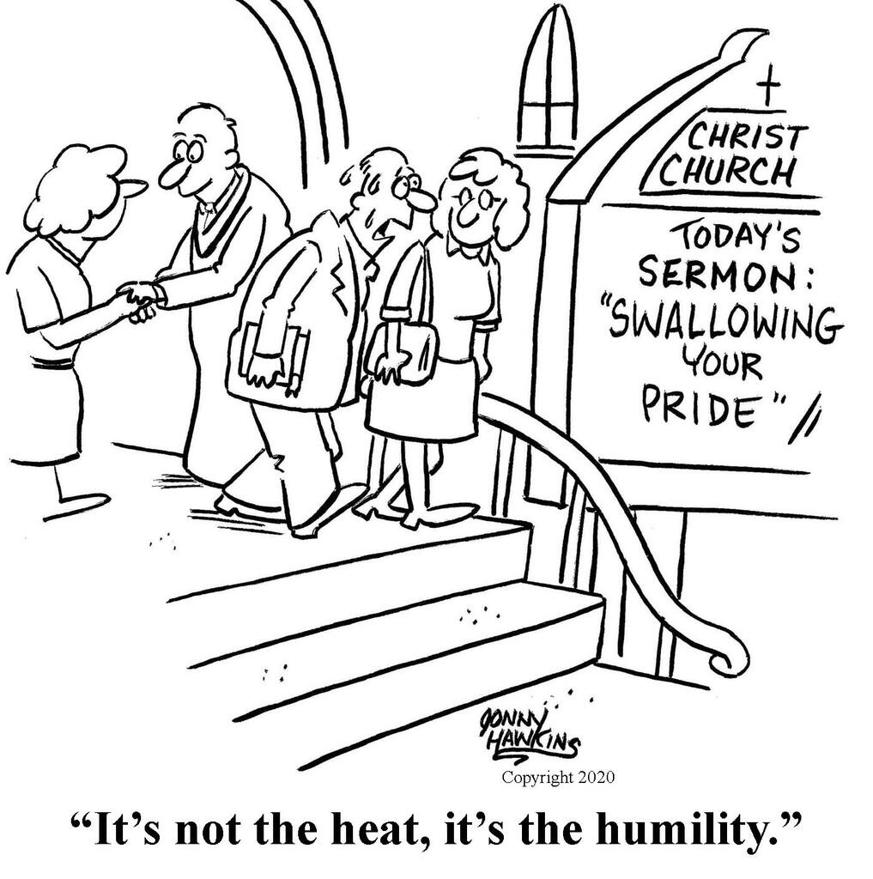Just For Fun

Freedom From Anxiety

1 PETER 5:7

1. BE NOT ANXIOUS
   1. EAT DRINK WEAR

MATTHEW 6:25-34 _______________________________________

PHILIPPIANS 4:6 – 6do not be anxious about anything, but in everything by prayer and supplication with thanksgiving let your requests be made known to God.

_________________________________________________________

* 1. TRUST

PSALM 115:11 – 11You who fear the LORD, trust in the LORD! He is their help and their shield. ___________________________________

PROVERBS 3:5 – 5Trust in the LORD with all your heart, and do not lean on your own understanding.

________________________________________________________

* 1. GIVE IT TO GOD

1 PETER 5:7 – 7casting all your anxieties on Him, because He cares for you. __________________________________________________

1. PERSONAL CONCERNS
   1. SCHEDULE

LUKE 10:41 – 41But the Lord answered her, “Martha, Martha, you are anxious and troubled about many things.

________________________________________________________

* 1. SAFETY

MARK 4:37-40 – 37And a great windstorm arose, and the waves were breaking into the boat, so that the boat was already filling. 38But He was in the stern, asleep on the cushion. And they woke Him and said to him, “Teacher, do you not care that we are perishing?” 39And He awoke and rebuked the wind and said to the sea, “Peace! Be still!” And the wind ceased, and there was a great calm. 40He said to them, “Why are you so afraid? Have you still no faith?”

_________________________________________________________

PHILIPPIANS 1:21 – 21For to me to live is Christ, and to die is gain.

________________________________________________________

* 1. SPIRITUAL CHALLENGE

MATTHEW 19:19 – 19When they deliver you over, do not be anxious how you are to speak or what you are to say, for what you are to say will be given to you in that hour.

________________________________________________________

1. SALVATION CONCERNS
   1. SELF

1 JOHN 5:11-13 – 11And this is the testimony, that God gave us eternal life, and this life is in his Son. 12Whoever has the Son has life; whoever does not have the Son of God does not have life. 13I write these things to you who believe in the name of the Son of God, that you may know that you have eternal life.

_________________________________________________________

* 1. BELIEVERS

2 CORINTHIANS 11:28 – 28And, apart from other things, there is the daily pressure on me of my anxiety for all the churches.

________________________________________________________

GALATIANS 3:1 – 1O foolish Galatians! Who has bewitched you? It was before your eyes that Jesus Christ was publicly portrayed as crucified. ________________________________________________

* 1. NON-BELIEVERS

ROMANS 9:3 – **3**For I could wish that I myself were accursed and cut off from Christ for the sake of my brothers, my kinsmen according to the flesh.

_________________________________________________________