Thank you for worshipping with us this morning. We would love to know who you are.

Home Congregation: ________________________________________________

Name:___________________________________________________________________________________________

Address: ________________________________________
________________________________________________

We strongly desire the privilege to pray over, with, or for you. Please supply below your prayer needs and give this form to one of the Pearl Street members.

Faith: ___________________________________________
________________________________________________
Health: __________________________________________
________________________________________________
Relationship: _____________________________________
________________________________________________
Housing: _________________________________________
________________________________________________
Employment: _____________________________________
________________________________________________
Military: _________________________________________
________________________________________________
Other: ___________________________________________
________________________________________________

Worship In The Park
September 28, 2025

Today’s Sermon Topic:
Dinner With A Pharisee Ruler
Luke 14:1-11

Today’s Worship time is hosted by:
Pearl Street Church of Christ
330 Pearl Street, PO Box 380, Lynchburg, Ohio 45142
937-579-5025
WWW.pearlstchurchofchrist.com
WWW.Pearlstreetcofc@gmail.com
Facebook @ Pearl Street church of Christ
Minister …………… Paul Carpenter (513-375-9992)
Sunday Services
Bible Class ………..………………….. 9:30 AM
AM Worship …….…………………… 10:30 AM
PM Worship ..………………………….. 6:00 PM
Wednesday Service
Bible Study ……………………………….. 6:00 PM
Bible Correspondence Course and Home Bible Studies are available upon request.

Event room available for parties, meetings, or
other gatherings.
Call Gary Niehaus, 513-519-5783, for information and booking.
Welcome
Welcome to the Second annual Worship in the Park. We are excited to spend this time with you in worship and praise to our Lord. Our desire is that this time together not only serve as a time of praise, but also a time of fellowship and mutual faith in a risen Savior. May we all be blessed by being here, and may we leave uplifted by our time together before the throne of God.
Just A Thought
“From the story of Moses, Aaron and the 70 elders who ate and drank in the presence of God in Exodus 24 to the “marriage supper” in Revelation 19:9, shared meals are full of symbolism and meaning in the Bible. By sharing meals, we grow closer, stimulate one another spiritually and learn generosity.”
Erica Golden, “The Physical and Spiritual Benefits of Sharing a Meal”
Bible Quiz Time
What request did the Syrophoenician woman make of Jesus?
Today’s Bible Text
LUKE 14:1; English Standard Version
¹One Sabbath, when He went to dine at the house of a ruler of the Pharisees, they were watching Him carefully.
Just For Fun
If Jesus tried to feed the 5,000 today
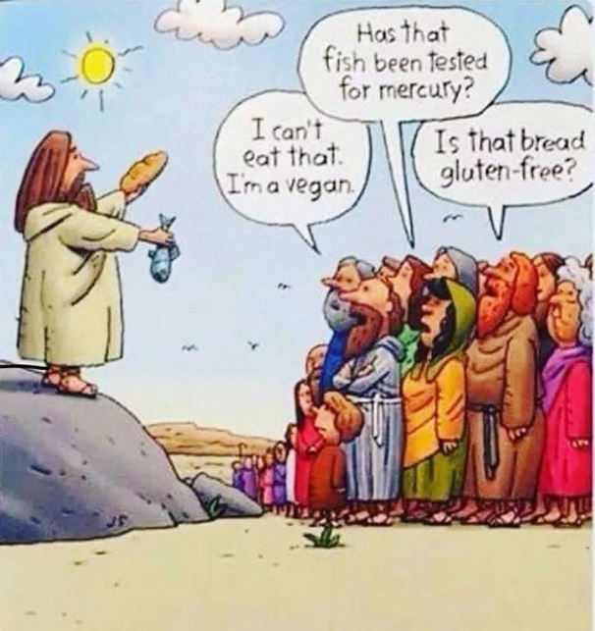
Answer to Bible Quiz Time
For Jesus to cast the demon out of her daughter, Mark 7:25.
Paul’s Portion
Most people are probably still familiar with Muhammad Ali. Ali was a heavyweight boxer who had an impressive career. His boxing career was so impressive that he famously claimed, “I am the greatest”. Harry Houdini practiced intensely to become the greatest magician and escape artist. The motivational speaker Zig Ziglar has said, “You don’t have to be great to start, but you have to start to be great”. Shakespeare, in his play “Twelfth Night”, has the line, “Some are born great, some achieve greatness, and some have greatness thrust upon them”. What is this fixation on greatness? Many people spend countless hours in the gym, in the lab, in the library, on the courts or on their computers all in the pursuit of greatness. This quest for greatness is not limited to personal greatness. Teams, businesses, even politicians strive to be the “greatest”. As most are aware, President Donald Trump’s platform was and is, “Make America Great Again” showing that the goal of greatness can be on a national level. These are examples from the world, but the Church is not immune to this grasp for greatness. In the Gospel according to Luke there is recorded two incidents where the disciples argued amongst themselves which of them would be the greatest, 9:46-48 and 22:24-27. There is also the incident where James and John requested to sit at Jesus’ right and left in His kingdom, Mark 10:35-45. In essence the two brothers were attempting to attain greatness. Still today, there are preachers, churches, disciples which are stiving to be the greatest. When faced with the pursuit of greatness Jesus taught His disciples that greatness is not something to strive after. Rather, in His kingdom it is the least and the servant who are the greatest. Perhaps one reason for the effort to be the greatest in sports, entertainment, business, even discipleship is to achieve bragging rights. Paul wrote to the Church is Galatia, “But far be it from me to boast except in the cross of our Lord Jesus Christ, by which the world has been crucified to me, and I to the world.” Galatians 6:14. Among Christ followers true greatness then is not in self-development and promotion. Rather it is in doing those things that promote Christ and the Gospel. It is heeding the advice of author Napoleon Hill, “If you cannot do great things, do small things in a great way." Do not attempt to improve the world, improve your corner of the world. With each Christian improving their speck of the universe by living like Christ, the world will be improved.

Dinner With A Pharisee Ruler
LUKE 14:1-11

- THE SET UP
  - THEY WATCHED
LUKE 14:1 – ¹One Sabbath, when He went to dine at the house of a ruler of the Pharisees, they were watching Him carefully.
________________________________________________________
MARK 3:2 - ²And they watched Jesus, to see whether He would heal him on the Sabbath, so that they might accuse Him.
________________________________________________________

  - COULD JESUS HEAL
LUKE 14:2 – ²And behold, there was a man before Him who had dropsy. __________________________________________________
MARK 9:22-23 – ²²And it has often cast him into fire and into water, to destroy him. But if you can do anything, have compassion on us and help us.” ²³And Jesus said to him, “‘If you can’! All things are possible for one who believes.”
_________________________________________________________

  - WOULD JESUS HEAL
MARK 1:21-31 – On the Sabbath Jesus casts out a demon and heals Peter’s mother-in-law. ______________________________________
MARK 3:1-6 – On the Sabbath Jesus heals a man with a withered hand. ____________________________________________________
JOHN 9:1-7, 14 – On the Sabbath Jesus heals a man born blind.
_________________________________________________________

- JESUS HEALED
  - JESUS’ QUESTION
LUKE 14:3 – ³And Jesus responded to the lawyers and Pharisees, saying, “Is it lawful to heal on the Sabbath, or not?”
_________________________________________________________
LUKE 14:4 – ⁴But they remained silent. …
_________________________________________________________

  - JESUS HEALS
LUKE 14:4 – ⁴But they remained silent. Then He took him and healed him and sent him away. _____________________________________
MATTHEW 12:8 – ⁸For the Son of Man is lord of the Sabbath.
_________________________________________________________
COLOSSIANS 1:16 – ¹⁶For by Him all things were created, in heaven and on earth, visible and invisible, whether thrones or dominions or rulers or authorities—all things were created through Him and for Him. ____________________________________________________
  - JESUS’ SECOND QUESTION
LUKE 14:5 – ⁵And He said to them, “Which of you, having a son or an ox that has fallen into a well on a Sabbath day, will not immediately pull him out?” ____________________________________________
LUKE 14:6 – ⁶And they could not reply to these things.
________________________________________________________
MARK 2:27 – ²⁷And he said to them, “The Sabbath was made for man, not man for the Sabbath. _______________________________

- TRUE HONOR
  - DON’T PRESUME
LUKE 14:8 – ⁸“When you are invited by someone to a wedding feast, do not sit down in a place of honor, lest someone more distinguished than you be invited by him. __________________________________
ROMANS 12:16 – ¹⁶Live in harmony with one another. Do not be haughty, but associate with the lowly. Never be wise in your own sight. ___________________________________________________
  - GIVE HONOR
LUKE 14:10 – ¹⁰But when you are invited, go and sit in the lowest place ... _________________________________________________
PHILIPPIANS 2:3 – ³Do nothing from selfish ambition or conceit, but in humility count others more significant than yourselves.
________________________________________________________
  - BE EXALTED
LUKE 14:11 – ¹¹For everyone who exalts himself will be humbled, and he who humbles himself will be exalted.
_________________________________________________________
1 PETER 5:6 – ⁶Humble yourselves, therefore, under the mighty hand of God so that at the proper time He may exalt you.
Welcome – Nate

Doxology
There is a God, He is alive

Opening Prayer – Nate

How Sweet How Heavenly
Come Let Us All Unite to Sing, God is Love
Blessed Assurance
It Is Well With My Soul

Scripture Reading – Brian

Message – Paul

What Can Wash Away My Sins

Jesus Keep Me Near The Cross

Lord’s Supper – Dennis

When We All Get To Heaven

Closing Prayer – Glenn

Announcements – Jerry

Welcome – Nate

Doxology
There is a God, He is alive

Opening Prayer – Nate

How Sweet How Heavenly
Come Let Us All Unite to Sing, God is Love
Blessed Assurance
It Is Well With My Soul

Scripture Reading – Brian

Message – Paul

What Can Wash Away My Sins

Jesus Keep Me Near The Cross

Lord’s Supper – Dennis

When We All Get To Heaven

Closing Prayer – Glenn

Announcements – Jerry

