Those Privileged to Serve Today Next Sunday
(Subject to change please check each Sunday morning)
Song Leader ………………. Dennis …………….. Nate
Opening Prayer ……………. Dennis …………….. Nate
Scripture Reading ………..... Glenn …………… Dennis
(ROMANS 8:12-17)
Lord’s Table (Talk & Prayers). Paul ………………. Gary
Closing Prayer …………….. Gary ………………. Glenn
Announcements …………… Jerry ………………. Paul
Greeters …………………… Paul & Angela .. Glenn & Mary
Communion Preparation for October ………… Kendra

September / October Birthdays
Mel 9/12 Patty 9/16 Jerry 9/17
Angela 10/30

September / October Anniversaries

Weekly Budget – $1,250

Bible Correspondence Course and Home Bible Studies are available upon request.

Event room available for parties, meetings, or
other gatherings.

Call Gary Niehaus, 513-519-5783, for information and booking.

Pearl Street
Church of Christ

330 Pearl Street, PO Box 380
Lynchburg, Ohio 45142
937-579-5025
WWW.pearlstchurchofchrist.com
WWW.Pearlstreetcofc@gmail.com
Facebook @ Pearl Street church of Christ

Sunday Services
Bible Class ………..………………….. 9:30 AM
AM Worship …….…………………… 10:30 AM
PM Worship ..………………………….. 6:00 PM

Wednesday Service
Bible Study ……………………………….. 6:00 PM

Minister …………… Paul Carpenter (513-375-9992)

September 27, 2026
ADOPTED IN
Ephesians 1:5

Welcome
Welcome to services at the Pearl Street church of Christ. If you are a visitor, know that you are an honored guest. You are invited to join us every time we come together for worship or for Bible study. If you have any questions about God, Jesus, Holy Spirit, Bible, Christianity, the worship service, or the Church of Christ in general we would love to study with you to answer those questions.

Just A Thought
“When we think about the concept of adoption, we often reflect on how someone chooses us even when we might not feel worthy. Similarly, when it comes to our relationship with God, we come to realize that He has lovingly chosen us to be part of His family. This is not just a mere accident; rather, it’s an intentional act of love. In our journey, we understand that being adopted by God illustrates the depth of His love for us. He takes us as we are, with all our imperfections, and desires us to know that we belong to Him. ”. Biblestudyforyou.com

Weekly Memory Verse
GENESIS 8:22 – ²²While the earth remains, seedtime and harvest, cold and heat, summer and winter, day and night, shall not cease.

Bible Quiz Time
Esau’s wife Basemath was the daughter of who?

Today’s Bible Text
Ephesians 1:5; English Standard Version
⁵He predestined us for adoption to Himself as sons through Jesus Christ, according to the purpose of His will.
Paul’s Portion
There are many different cultures in this world. In the many different cultures there exist also many different ideas of what is considered food. These different views on good cuisine have at times elicited the comment of “What on earth are you eating”? Some people cannot believe the sort of things other people eat in other cultures. Upon hearing of some delicacies, it is not uncommon for people to comment that they would never eat such strange foods. They may even comment that eating the item would make them sick or even kill them. Perhaps this attitude is a bit dramatic. Unless you have a violent allergic reaction to the food item, if it is eaten by some cultures than you also can most probably eat it without fear of dying. Jesus sort of addresses this topic in Mark 7:18-19 where He states, “Then are you also without understanding? Do you not see that whatever goes into a person from outside cannot defile him, since it enters not his heart but his stomach, and is expelled?" (Thus he declared all foods clean.)” Thus, eating strange and new foods will not really affect you much for it passes quickly through your system, (some more quickly than others). What, however, about the spiritual food that you consume. We are to digest the word of the Lord as it is recorded that Ezekiel and John did, (Ezekiel 3:1-2, Revelation 10:9). At times, though, we may observe people and exclaim “What is that you are feeding to your spirit?” It is a strange food that is not like the food of the scriptures. The people reply with “I like the taste of this better,” or “I prefer the feeling that I get when I eat this.” The argument is made that they may eat what “Spiritual food” they want because people and cultures are different. It is further explained that you may not like what they are feeding their spirit, but they do. The problem with this attitude is that spiritual food and physical food are not equal. When Jesus was talking about food not defiling the body He made mention that it was because it was not entering the heart. It stands to reason then that if there is a food that does enter into the heart than it can defile a man. The food that enters the heart is the spiritual food. We then need to be careful of what we feed the spirit. Spiritual food is not tempered by culture, time, or space. Nor is it subject to recipe experimentation. Spiritual food is defined by scripture. We are to consume the word of God as delivered and prepared by God, Jesus, and the inspired writers. Man’s recipes can’t measure up to God’s.
Reprinted and amended from 10/30/11
Plan Ahead and Mark Your Calendars
(Dates are subject to change)
Today’s fellowship meal has been cancelled. We apologize
for any inconvenience.
The next Ladies Night Out is this Thursday, October 1st.
Our next Service in Song is Sunday, October 4th.
The Next Men’s Breakfast is Saturday, October 10th.
October 17th – “Night of the Untalented Show”
The next Fellowship Meal will be October 25th.
October 29th is “Beggars Night” in Lynchburg. We will be
handing out goodies again this year. Please bring your
contributions by the 28th.
We will be combining the November and December
Fellowship Meals. This will be on December 13th.
Traveling
Nate & Kendra heading in Florida.
Sympathy
We extend our sympathy to Ginger in the passing of her cousin Tammy Garner.
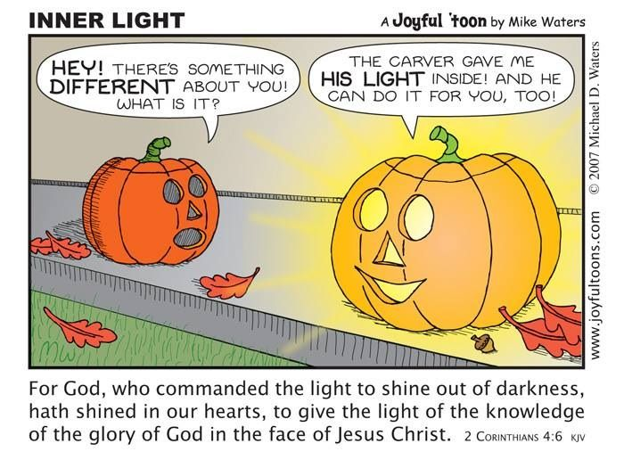
Just For Fun
Answer to Bible Quiz Time
Ishmael was the father of Basemath, Genesis 36:3.
Illness and Prayer Concerns
Please also see Monthly Extended list
Grant, continued strengthening and healing.
Betty, surgery on Thursday for pain.
Dennis, pinched nerve relief.
Jim Faust, cancer.
Remi, broken arm.
Diane West, recovery after fall.
Carol Banach, surgery recovery.
Connie Loveless, stroke recovery.
Dorcas Carpenter, Paul’s aunt, fall recovery.
Mary Bank, severe arthritis.
Amber, adequate oxygen issues.
Karen Schraw, kidney function.
Karl Flem, blood clots.
Linda Allen, shoulder procedure.
Britt Dean, possible eye procedure.
Westin Dean, seeing specialist about possible surgery.
Chase, Jonah’s cousin, personal struggles.
Pat, back pain
Angel Mahaney, sudden death of husband.
Josh Schraw, severe burns from a fire.
Rebecca Abel, friend of Kendra, cancer.
Steve Davis, recovery from double lung transplant.
Carolyn Wood, hip
Ebbie Van Pelt, Martha’s sister, heart surgery recovery.
Darcy Hedges, recovery from variety of health issues.
Jarod Storer, cardiac and kidney issues.
Mona Greer, strengthen health.
Toni, strengthening of mind and body.
Nancy Shaffer, strength
Military: Jacob Batterton, Amber Smith, Brady Smith

ADOPTED IN
Ephesians 1:5

- CHOSEN.
  - PREDESTINED.
Ephesians 1:5 – ⁵He predestined us for adoption to Himself
________________________________________________

  - LED
ROMANS 8:14 – ¹⁴For all who are led by the Spirit of God are sons of God. __________________________________

  - HIS WILL.
Ephesians 1:5 – … according to the purpose of His will.
________________________________________________

- CHILDREN.
  - SONS.
Ephesians 1:5 – ⁵He predestined us for adoption to Himself as sons … _______________________________________

GALATIANS 3:26 – ²⁶for in Christ Jesus you are all sons of God, through faith. _________________________________

ROMANS 8:14-17 – ¹⁴For all who are led by the Spirit of God are sons of God. _______________________________

  - INTIMATE.
1 JOHN 3:1-2 – ¹See what kind of love the Father has given to us, that we should be called children of God and so we are
________________________________________________
ROMANS 8:15 – ¹⁵For you did not receive the spirit of slavery to fall back into fear, but you have received the Spirit of adoption as sons, by whom we cry, “Abba! Father!”
________________________________________________

  - MATURING.
1 JOHN 3:2 – ²Beloved, we are God’s children now, and what we will be has not yet appeared; but we know that when He appears we shall be like Him, because we shall see Him as He is. __________________________________

- CHRIST’S.
  - THROUGH JESUS.
Ephesians 1:5 – ⁵He predestined us for adoption to Himself as sons through Jesus Christ…
________________________________________________

  - FELLOW HEIRS.
ROMANS 8:16-17 – ¹⁶The Spirit Himself bears witness with our spirit that we are children of God, ¹⁷and if children, then heirs—heirs of God and fellow heirs with Christ, provided we suffer with Him in order that we may also be glorified with Him. ________________________________________

  - BY BAPTISM.
GALATIANS 3:25-27 – ²⁵But now that faith has come, we are no longer under a guardian, ²⁶for in Christ Jesus you are all sons of God, through faith. ²⁷For as many of you as were baptized into Christ have put on Christ.
________________________________________________

